Graphic representation in technological projects

Author: Guillermo Gómez
Revision: Pablo Rivas Martín

Contents
1 Prior knowledge 2
2 Keywords 2
3 Mindmap of the unit 2
4 Introduction 3
5 Graphic materials 3
6 Drawing tools 4
7 Scale and dimensions 6
8 Graphic systems 7
9 Introduction to perspective 8
10 Dimensions in the drawing 9

Prior knowledge
Activity: Summarize your general knowledge on this topic.

Keywords
Activity: Copy following keywords, explaining their meaning and translate them into Spanish.

lead |  | reduce
graphite |  | enlarge
clay |  | plane
size |  | projection
format |  | height
segment |  | width
angle |  | depth
vertex / vertices |  | front view
set square |  | side view
edge |  | overhead view

Mindmap of the unit
Activity: Analize and try to understand following mindmap

Introduction
Activity: Think about the following questions: Why do we draw? What types of drawing do you know? How are they different? Which one do you think is most appropriate for technology? What type did you use in the design section of your first project?

Definition:
Technical drawing (or graphic representation) is an universal conventional language, bound by specific rules, which makes it possible to transmit all the information needed to manufacture an object.

Graphic materials
Activity: Think about the following questions: What materials do we use for technical drawing?

To represent an object we need two basic elements: the support (usually paper) and drawing instruments (usually pencil).

Support
Paper is the most commonly used support for technical drawing.

There are different sizes of paper. These sizes are standardized and are called formats. The most common format is the DIN A-4 (210x 297 mm; DIN=Deutsche Industrienorm).

Activity: Copy from the board the formats with different colours and how they are bound by the “folding rule”.

“Folding rule”: For each format, the rule is that:
- Its surface area is half of the previous format.
- Its length is the width of the previous format.
- Its width is half the length of the previous format.

Sizes of the formats
Format | Width (mm) | Length (mm) | Surface (m²)
DIN A-0 | 841 | 1189 | 1
DIN A-1 | 594 | 841 | 0,5
DIN A-2 | 420 | 594 | 0,25
DIN A-3 | 297 | 420 | 0,125
DIN A-4 | 210 | 297 | 0,0625
DIN A-5 | 148 | 210 | 0,0312
DIN A-6 | 105 | 148 | 0,0156

Drawing instruments
Pencils (or the propelling pencil) are instruments that contain a bar of graphite and clay, called lead, incased in a wooden support (or metal or plastic tube). The lead is softer (dark lead) or harder (grey lead) depending on the amount of graphite it contains.

Activity: Draw lines with pencils of different hardness (exchange with your partner if necessary) and pay attention to the tone, letter and number on the pencil.

Standard of lead hardness
HARD |  |  |  | MEDIUM |  |  | SOFT
5H | 4H | 3H | 2H | H | F | HB | B | 2B | 3B | 4B
Technical drawing |  |  |  | Technical and artistic drawing |  |  | Artistic drawing

How it’s made: Pencils (video)
https://www.youtube.com/watch?v=88wM22q5cd8
How it’s made: Graphite lead (video) https://www.youtube.com/watch?v=zkP3i1MQJWA

Drawing tools
The rubber
There are basically two types of rubber: soft rubber for erasing the traces of soft pencils, and hard rubber for erasing that of hard pencil or ink. When using the rubber, first make sure it is completely clean and then move it gently in one direction on the surface of the paper.

The compass:
This instrument is used to draw curved lines and to carry over distances.
Activity: In your notebook, draw your compass freehand at full scale (1:1), indicating its different parts. This drawing is called a sketch.

Activity: Use of the compass
Draw a circle of 20 mm in diameter and concentric to it two more circles of 30 mm and 40 mm of diameter.

The ruler:
This instrument is used to draw straight lines and measure segments. In order to measure properly, one must:
- Put the 0 line at the beginning of the segment,
- Read the measurement at the point of the ruler that matches the end of the segment
- Write the measurement in cm with a decimal to express the mm.
Activity: Measure the sizes of your project.
Protractor:
This instrument is used to measure and draw angles:
- Align the line of reference (0º-180º) with one of the sides of the angle (X), and the centre of the protractor with the vertex of the angle (Y)
- Read the measurement of the angle at the intersection of the opposite side of the angle (Z) and the graduated semicircle of the protractor.
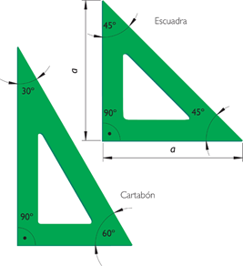
- Write the measurement of the angles in degrees, using the symbol º.

Set squares:
Set squares are two triangles used for drawing parallel and perpendicular lines:
- Triangle with 90º, 45º and 45º angles (escuadra)
- Triangle with 90º, 60º and 30º angles (cartabón)

To draw parallel and perpendicular straight lines you simply slide the first triangle (escuadra) over the hypotenuse of the second triangle (cartabón).

Activity: Use of the set square

Draw six squares with 5 cm sides and
-Nº 1: Draw two crossing lines and measure and express the angles
-Nº 2 to 6: fill them with parallel lines that should be:
-Nº 2: horizontal, 10 mm apart
-Nº 3: vertical, 10 mm apart
-Nº 4: inclined, with a 45º angle and 10mm apart
-Nº 5: inclined, with a 60º angle and 10mm apart
-Nº 6: inclined, with a 30º angle and 10mm apart

Scale and dimensions
Scale
The scale is the proportion (relationship) between the size of the drawings and the size of the real object.
Scale = | Size of the drawing
Scale = | Size of the real object

In technical drawing, we use different types of scales.

Types of scale | Which is larger? | Examples
Full scale (escala natural) | None. Both are the same size. | 1:1
Reduced scale (escala de reducción) | The object. | 1:2 ; 1:3
Enlarged scale (escala de ampliación) | The drawing. | 2:1 ; 3:1

What is a scale drawing (video):
http://www.virtualnerd.com/middle-math/ratios-proportions-percent/scale-drawings-models/scale-drawing-definition

Dimensions
The dimensions of the drawing show the real measurements of an object. They help us understand the drawing.

Activity: Copy the following exercises and solve them in your notebook

- Write these grades of pencils in order from the hardest to the softest: 2H, H, 3B, 5H, HB, 6B, 3H

- Match each adjective to its antonym: Thick, Small, High, Soft, Big, Thin, Hard, Low.

- Draw the angles 15º, 30º, 45º, 60º, 75º, 90º, 105º, 120º, 135º, 150º, 165º and 180º using the set squares. (clue: 15º = 45º-30º, 75º = 45º + 30º, 105º = 60º + 45º, 120º = 180º-60º....)

- Make the following patterrn
  - Draw a straight line 15 cm long
  - Divide it into 3 cm segments
  - Use each division mark as the centre of a circle with a 2 cm radius
  - Use the same centres to draw circles with a 1,5 cm radius
  - Colour the pattern

- Draw your pencil sharpener at these scales: a) 1:1, b) 1:2 and c) 2:1

- Select the correct adjective for each statement:
  - An object is smaller/larger than the drawing in an enlarged scale
  - The drawing in an enlarged / a reduced scale is smaller than the object

- What scale would you use to draw a fork on a A4 paper? What scale would you use for a chair?

Graphic systems
An object can be represented in different ways or graphic systems. Depending on the drawing tools and instruments used, the graphic system can be:

Graphic System | Characteristics | Example
Sketch  (boceto) | - Freehand  - Clarity and imagination
Sketch with measures or diagram  (croquis) | - Freehand  - Incorporates all data and dimensions
Plan  (plano) | - With ruler, compass...  - Use of a scale

Activity: In Unit 1 you drew the workshop. Was it a draft, a sketch or a plan? Why? And what about the drawing you made of your compass or your first project?

Rule for drawing:
First draw using a hard lead (i.e. F or H) and once you are sure, trace darker lines using a soft lead (i.e. HB or B).

The views of an object:
The different views of an object are the images produced when we look at it from different positions; (it is like placing the object suspended between three planes perpendicular to one another and project the object on them).

View of the object | We look at the object from | We say the object is projected perpendicularly onto
Front view (alzado) | the front | Vertical Plane
Side view (perfil) | one side | Profile Plane
Overhead view (planta) | above | Horizontal plane

According to the European standard, the overhead view is always drawn below the front view, and the lateral view is drawn to the right (left) of the front view (see image).

Activity:
Copy from the board the three views of an object (i.e. eraser).
Draw the three views of your sharpener at a scale of 2:1.
Work with the computer to solve the view-exercises proposed by your teacher
View exercises (website)
http://www.educacionplastica.net/3dcube_model/vistas_3d_2x2.html

Introduction to perspective

Perspective is the representation on a plane (2 dimensions) of an object (3 dimensions).

As drawing boxes in perspective is easy, we can use them to draw any object in perspective, following these 3 steps:

- 1st) the object is “divided” into several boxes, which are represented in perspective
- 2nd) the details of the object are included in the boxes, paying attention to the proportions
- 3rd) the unnecessary lines are erased and the edges are profiled.

Activity: Draw your sharpener in perspective.

Dimensions in the drawing

When you have a diagram or a finalized plan, it is essential to include all the dimensions.
In this way, the person that is making the object will have the sizes associated with each one of the pieces.
The dimensions of parts are standardized
- We put the dimensions of the sides, radius, etc. and the angles.
- The longitudes are expressed always in millimeters, unless otherwise indicated. Therefore, only the number is written, without putting the unit, since this is already understood.
- The angles are expressed from zero to 360 degrees.
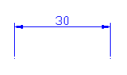
- The dimension figures always indicate the real measure of the element (if the drawing is to scale or not)
- Dimension figures are written on lines limited to two extreme arrows that are called dimension lines. In addition, they are delimited by the auxiliary lines of dimension, which are two lines perpendicular to them. All of them are fine and continuous.
- Make sure that the dimension lines are never crossed, so that the drawing is clear.
- Put only the necessary dimensions. Do not duplicate information.

Example: Observe how this figure would be bounded and ready to be made.
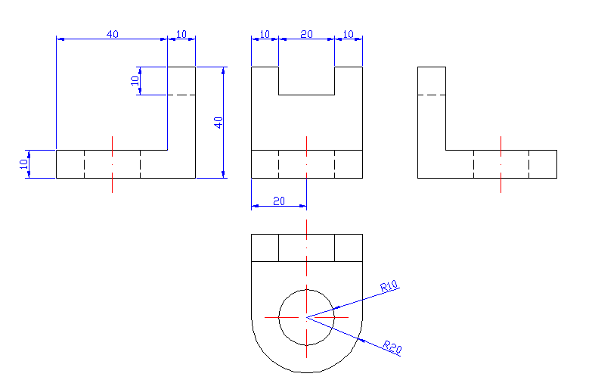
Activity: Put the dimensions in the views of your pencil sharpener

