Unit 7 – The Habsburgs

Index
1. Origin of the house of Habsburg 2
2. Charles I. (1500 - 1516 - 1558) 3
2.1. Inheritance of Charles I 3
2.2. Internal Problems 4
2.3. International Relations 6
2.4. Legacy 8
3. Philip II. (1525 - 1556 - 1598) 10
3.1. Philip II's Government 10
a) Politics 10
b) Religious issues 10
c) Annexation of Portugal 11
d) Economy 11
e) Society 12
3.2 Foreing Policy 12
a) France 12
b) Ottoman Empire 13
c) Revolts in Flanders 13
d) Rivalry with England 14
3.2. Cultural Legacy 14
4. Minor Austrias. General Introduction. 15
4.1. Philip III 1578 – (1598) - 1621 15
4.2. Philip IV 1605 – (1621) - 1665 16
Cultural and artistic legacy 17
4.2. Charles II 1661 (1665) 1700 17

1. Origin of the house of Habsburg
The Catholic Monarchs put in practice a well programmed marriage policy. They married all their descendants with different European monarchies in order to isolate the main enemy of Ferdinand II, that was France.
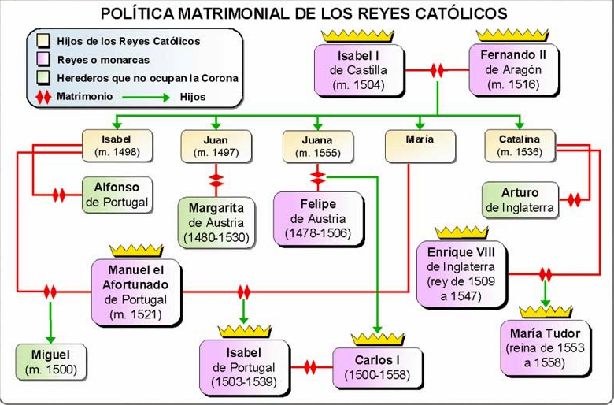
After the death of the first and second heirs Juana would be proclaimed as the legal heir of the Crown of Castile and the Crown of Aragon. If she would have ruled she would have unified both crowns the first time in history.
When Isabel died, in 1504, in her testament she asked to Fernando to rule in Castile in case that Juana was not able to rule because of her mental instability.
At the end Philip the Handsome would be the person that ruled in Castile, but he only ruled till 1506 when he suddenly died.
From 1506 to 1516 Castile will be ruled by a regency of Ferdinand and Cardinal Cisneros.
When Fernando II died, in 1516, Charles came to the Iberian Peninsula with only 16 years old in order to be proclaimed king, although his mother Joanna was still alive.
But that is another story.

2. Charles I. (1500 - 1516 - 1558)

2.1. Inheritance of Charles I
Charles I will be the first king of a new dynasty, the Habsburgs.
Due to a very well programmed marriage policy Charles I will inherit a wide range of territories and he will also become emperor of the west.
Here you have a list and a map with the territories that he inherited.
- From his mother's side:
  - From Isabella, his grandmother: Castile, Navarre, Granada, Canary islands, some territories in north Africa and the new territories recently discovered in America.
  - From Ferdinand, his grandfather: Crown of Aragon, Naples, Sicily and Sardinia.
- From his father's side:
  - From Mary of Burgundy: Artois, Flanders, The Netherlands, Luxembourg, Charolais and the Franche-Comté.
  - From Maximilien, emperor of Austria: Austrian territories and the title of emperor. (That means that he could be chosen emperor).

Charles didn't inherit all the territories at the same time, this is the real order.
- In 1515, when he was declared of age he would inherit The Netherlands, Luxemburg, Charolais and Franche-Comté. (Remember that in 1506 his father had died, but Charles was only 6 years old and his aunt, Margarita of Austria, was in charge of the regency).
- In 1516, when Ferdinand I died Charles came to the Iberian Peninsula in order to be claimed king in Castile and in Aragon. The only problem was that Joanna was still alive and some people considered that there couldn't be two monarchs. Due to the incapability of Joanna finally Charles will be crowned king as Charles I, while Joanna kept the title of queen of Castile.
- In 1519 the emperor Maximilien died. Charles will inherit the Austrian territories and the possibility of being chosen emperor of the Holy Roman Empire (el Sacro Imperio Romano Germánico). As soon as his grandfather Maximilien died Charles I asked for money in the Cortes of Castile and Aragon and went to Austria in order to get the title of emperor. The Cortes in Castile and Aragon were very angry because Charles had abandoned the Iberian Peninsula and some internal problems started in the Spanish Monarchy.
In 1520 Charles was chosen emperor of the Holy Roman Empires and he will be known as Charles V.

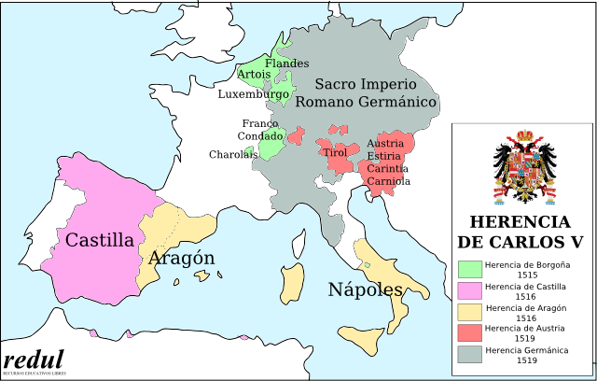

2.2. Internal Problems
When Charles I arrived to Spain he was a very young prince (he was only 16 years old) that couldn't speak Spanish or Catalan and who didn't know how the institutions worked.
He was surrounded by Flemish (flamencos) counsellors who were given important ecclesiastical and political positions. These counsellors received many rents and benefits from these privileges.
He only stayed for three years and in these years he was not a wise ruler. He gave privileges to foreigners, he didn't listen to the “Cortes”, he couldn't speak Spanish and Catalan, and he abandoned the territories in 1519, in order to claim his right as emperor, asking for more money to the Cortes.
Many social groups were very angry and many revolts occurred in Castile in Aragon. These are the revolts.

The revolt of the Comuneros in Castile (1520-1521)
This revolt started because Charles I was not respecting the legality of the Cortes, because he gave privileges to foreigners, because he was asking for money for his coronation as emperor and because he was abandoning the territories of Castile.
The cities that revolted were many; some examples are Toledo, Salamanca, Segovia, Zamora, Madrid...
The social groups that took part in this revolt were the low nobility and the bourgeoisie of the cities. The high nobility didn't support the revolts at the beginning and at the end they chose to help the king.
Some leaders that you may have heard of are Juan de Padilla and his wife María Pacheco, Juan Bravo and Francisco Maldonado. All of them, except María Pacheco that could escape to Portugal, were executed after the defeat of Villalar in 1521.
In the battle of Villalar in 1521 the comuneros were defeated by the royal army and the revolt was finally suffocated.

The revolt of the Brotherhoods (Germanías) 1521-1523.
This revolt took place in Valencia and in Murcia. In the cities the artisans wanted to have access to the local governments and in the rural areas the peasants fought against the feudal control of the lords. It was a revolt against the control of the nobility in the cities and in the countryside.
There were many military confrontations and the “Germanías” managed to defeat the royal army.
Finally they were defeated and seriously repressed.

2.3. International Relations
The vast empire that Charles I had inherited implied a very complex foreign policy with different conflicts with France, the Lutherans and the Ottoman Empire.

France, common interests and personal rivalry
The conflict with France was based on a personal rivalry between Francis I (Francisco I), king of France and Charles I. Both were interested in controlling the same territories. There were many confrontations and alliances, with important victories and defeats for both opponents.
One important battle was the battle of Pavia (1525), when Francis I was taken prisoner and sent to Madrid as a hostage.
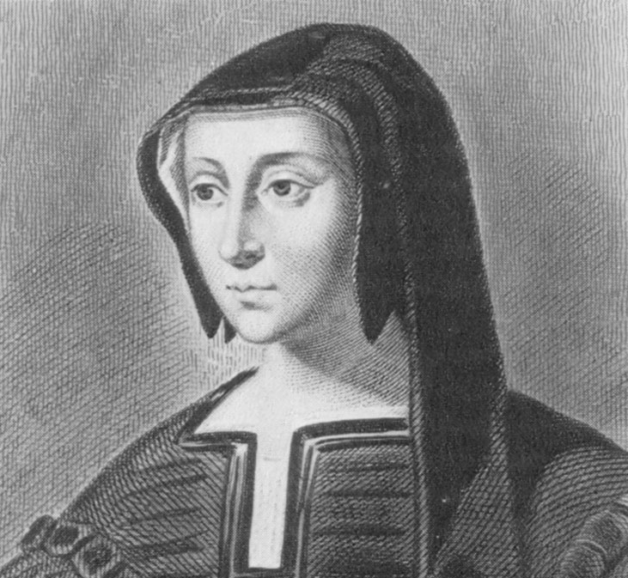
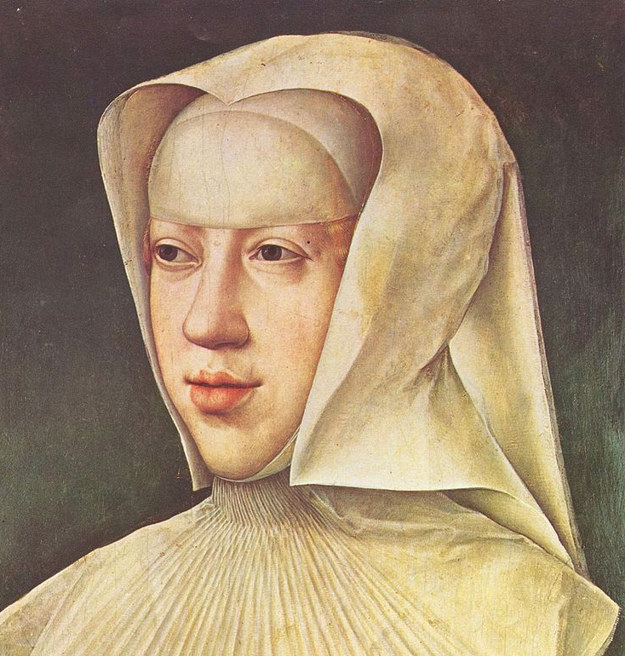
Finally the situation was solved in a diplomatic way in 1529 thanks to the Treaty of Cambrai, also known as “The Ladies' Peace” where the hegemony of Charles was imposed. Charles will keep the control of Milan, Flanders, The Netherlands, Artois, the Franche-Comté and the city of Tournay, while Francis I will control the Duchy of Burgundy.
Interesting Information
The Ladies' Peace is called like that because it was performed by Louise of Savoy (mother and former regent of Francis I) and Margaret of Austria (aunt, tutor and former regent of Charles I). This treaty was signed in 1529 in Cambrai, a city in the north of France.
Margaret of Austria could also have been the queen of Spain, as she was married to Juan, the first son of the Catholic Monarchs and the heir of the Crowns of Castile and Aragon. Six months after the wedding the prince John died of smallpox.

The Ottoman Empire
The other source of problems for Charles I was the Ottoman Empire. The emperor was Suleiman, the Magnificent and he ruled a vast and prosperous empire that stretched from Asia to Africa and Europe
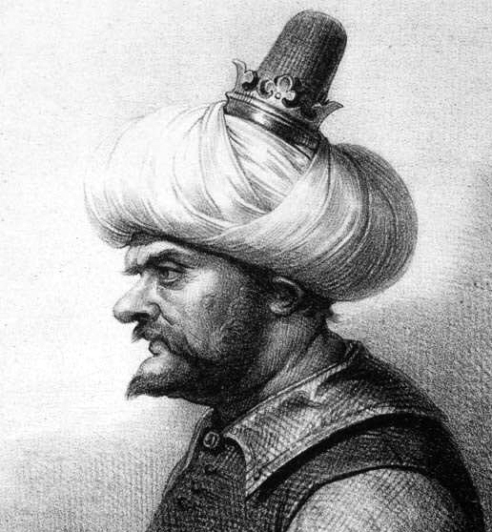
This empire caused many problems in the Mediterranean, in north Africa and in continental Europe.
Barbarossa (Barbarroja) was a very famous corsair or pirate that attacked the Spanish coasts ferociously, destroying villages, taking hostages and transporting Moriscos to North Africa.
He conquered Alger and became governor of that city.

- In the Mediterranean and North Africa there were constant confrontations between the navies of Charles I and Suleyman. In these confrontations Alger and Bougie were lost.
- In continental Europe the Ottoman Empire was a serious threat. After the battle of Mohacs in 1526 the Turks incorporated many territories of Hungary, and in 1529 they sieged (sitiar) the Imperial city of Vienna.
The German princes and the Lutherans
The problem with the Protestants started in 1517, when Luther wrote his 95 theses. It was not only a religious problem, but also a political problem, because many German princes supported the new faith because they would be able to control more easily the religious institutions and taxes, and also because they could gain more independence from the emperor.
Charles V tried to achieve consensus and convoked the Diet of Worms were many religious personalities could discuss about this religious problem. Luther was invited to this Diet, but he didn't change his mind and finally he was excommunicated.
The emperor also fought against the Protestant German princes. In the battle of Mühlberg (1547) the Protestants were defeated by the Imperial army.
Anyway this problem was not really solved and finally the religious division of Germany was accepted and confirmed in 1555. (Any prince could follow in his kingdom the religion that he wanted).
ABDICATION
The 16th of January, 1556 Charles V abdicated and let the Austrian territories and the crown of emperor to his brother Ferdinand, and the Spanish Monarchy, The Netherlands, Milan and the new territories in America to his son Philip.
Charles V died in the monastery of Yuste in 1558.

2.4. Legacy
Charles V is still remembered for the great contributions and transformations that he brought to History.
- He started a new dynasty “The Habsburgs” that will last almost two hundred years in the Spanish Monarchy.
- The crowns of Castile and Aragon were finally united under only one ruler.
- It was the first and only time that the title of emperor was held by a Spanish monarch.
- The Spanish Monarchy will start a new era in International Relations being transformed into a major power.
- A new alliance with the Austrian Habsburgs started. This alliance will drag the Spanish Monarchy to many European wars.
- In America a huge empire was being created. During the kingdom of Charles I, in 1521 Hernán Cortés defeated the Aztecs and created the Viceroyalty of New Spain (Virreinato de Nueva España); in 1522 Magallanes and Elcano circumnavigated the world; and in 1532 Pizarro defeated the Incas the Viceroyalty of Peru was finally created in 1542.
- Regarding his cultural legacy we can say that thanks to Charles V, Classical Renaissance fully entered in the Spanish Monarchy. We can enjoy masterpieces of the painter Titian, of the Spanish architect Machuca (who constructed the palace of Charles V in the Alhambra), and of the sculptor Leone Leoni.
- He also reformed the “Alcázar” of Madrid that will be the residential palace of his son Philip.

3. Philip II. (1525 - 1556 - 1598)

3.1. Philip II's Government
As we have seen before Philip II didn't inherit the title of emperor, thanks to that he was able to focus all his attention in the rest of his possessions, especially the Spanish territories.

a) Politics
He developed an authoritarian monarchy, that was a very centralised administration where the king is the highest authority and controls domestic and international policy. He established the capital city in Madrid where bureaucracy developed.
The institutions that represented the power of the monarch were Councils (Consejos, they were like ministries), “Corregidores” (they represented royal authority in local areas) and an increasing team of civil servants.
Here you have a diagram that shows the system of councils under Philip II

King

Advisory Councils
Ministerial Councils
Territorial Councils

- Taxes
- Crusades
- Military Orders
- The Inquisition
- State Affairs
- War
- Castile
- The Indies
- Aragon
- Italy
- Portugal
- Flanders

As the power of the king was increasing at the same time the power of the Cortes was decaying. They were rarely convoked and their decisions were not considered.

b) Religious issues
Regarding religious issues Philip II was also a defender of the Catholic religion inside and outside his possessions. Because of these ideas in the Iberian Peninsula he followed these three objectives:
- He fought against Protestantism
- He supported the Inquisition that persecuted Protestants and Converts. (“Conversos”, former Jews and Moors converted to Catholicism)
- He repressed the Moriscos. They were forbidden to use their language, clothes and traditions. Due to this policy there was a rebellion in Granada, “The Rebellion of Las Alpujarras” that lasted three years and was finally repressed.

c) Annexation of Portugal
Another important matter was the annexation of Portugal (1580). When the king of Portugal died without an heir Philip II claimed the throne of Portugal, due to his dynastic rights.
With the annexation of Portugal the Spanish Monarchy also incorporated its overseas territories (territorios de ultramar) in Africa, Asia and America.
This new annexation created an empire of an incredible huge dimension.

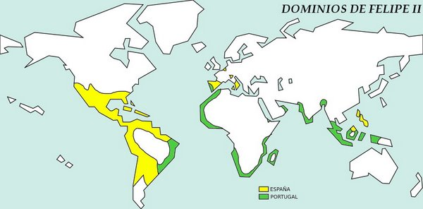

d) Economy
Referring to economy, during the 16th century (kingdoms of Charles V and Philip II) the prices of products rose (this phenomenon is called inflation). This inflation was caused by the constant arrival of gold and silver from America and the consequence was that the purchasing power was reduced and the standards of living decreased.

e) Society
Concerning society the population grew in all the 16th century.
The social groups were the privileged class (composed by the nobility and the clergy) and the non-privileged class (composed by peasants, artisans and bourgeoisie).
Other groups were the Moriscos (Muslims converted to Catholicism) and converted Jews (judíos conversos), these two groups suffered discrimination and repression.

3.2 Foreing Policy
The main problems that Philip II will have to confront during his kingdom were the rivalry with France, the attacks of the Ottoman Empire, the confrontation with England, and the revolt in Flanders.

a) France
The rivalry with France is a conflict inherited from the kingdom of Charles V.
France wants to get territories that belong to the Habsburgs and also longs for the European supremacy. This conflict is not going to last long and France will accept the supremacy of the Spanish Monarchy for one century.
The Spanish Imperial army defeated the French army in the battle of Saint Quintin (1557).
Two years later the Peace of Cateau Cambrésis (1559) was signed. Thanks to this treaty the confrontation with France was finally solved.
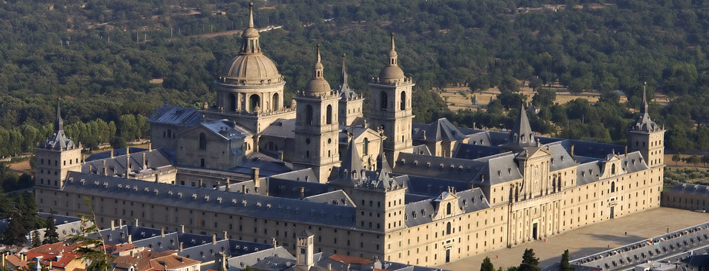
Battle of Saint Quintin
In order to commemorate this victory Philip II ordered the construction of the Monastery of El Escorial. An incredible masterpiece of architecture and art.
Marriage with Elisabeth of Valois
The Peace of Cateau Cambresis was consolidated with the marriage of Philip II and Elisabeth of Valois, daughter of the Henry II, king of France.

b) Ottoman Empire
The Ottoman Empires was a powerful empire and a prominent major power of this period.
It supposed a menace to the Spanish possessions in the Mediterranean.
Philip II created a Holy League of many states that defeated the navy of the Ottoman Empire in the famous naval battle of Lepanto in 1571.

c) Revolts in Flanders
The northern part of Flanders adopted the Calvinist religion, also known as Puritanism.
Philip II repressed these religious ideas in 1566, but the Northern provinces will resist in a long struggle that lasted more than 80 years and three kingdoms.
Many soldiers were sent to Flanders and they were known as the “Tercios de Flandes”. These soldiers created many problems due to the frequent pillaging and looting (saqueos) and also because they caused many deaths.
Did you know....?
The provinces of the north (later called United Provinces) were the ones that started the revolt.
In the future they will be known as The Netherlands, they will remain independent and their official religion will be Calvinism. In the 17th and 18th century they will become a very prosperous country with colonies in Africa (Cape Town), America (Dutch Guianas), and Asia (Indonesia).

The provinces of the south will remain Catholic and loyal to the House of Habsburg. Nowadays they are known as Belgium and the main religion is still Catholicism.

d) Rivalry with England
The Spanish control of the Atlantic was seen as a menace by the queen Elisabeth I. Because of that England promoted by one side the corsairs that attacked the Spanish ships and by the other side they helped the Puritans of The Netherlands.
These both strategies caused the deterioration of the Spanish power and encouraged the king to prepare and invasion of England with the Spanish Armada, but the fleet was destroyed in a storm.

3.2. Cultural Legacy
Philip II was a lover of art and thanks to that we can enjoy incredible works of art.
Architecture
During his kingdom the massive monastery of El Escorial was built. As it was built by the architect Herrera this style is called Herreran style. It is characterized by an absence of decoration, straight lines and pure shapes such as spheres, pyramids...
In Madrid city we also have the bridge of Segovia, near to the Royal Palace, over the Manzanares river.

Painting
Philip loved ancient painters of Middle ages, such as Hyeronimus Bosch “El Bosco”, and thanks to that we have a great selection of his paintings in the Prado Musem.
El Greco was also a very important painter of this period, although not very appreciated by the king.
Other painters were Antonis Mor (Antonio Moro), Alonso Sánchez Coello, Juan Pantoja de la Cruz, or the woman painter Sofonisba Anguissola.
Literature
In literature the Mystic literature flourished, with poets such as Santa Teresa de Jesús and San Juan de la Cruz.
The mystic literature is based on a contemplative state of mind, where the poet describes the meditation process as a deep and very special relation between the believer and God.
In the image gallery we can read a poem of San Juan de la Cruz.

----------xxxooo0oooxxx----------

4. Minor Austrias. General Introduction.
The last three Austrias are called the minor Austrias (Austrias menores) due to the fact that the 17th century was a century of general crisis. The Spanish monarchy suffered a severe economic crisis, tremendous demographic losses (because of the spread of diseases such as the Black Death) and military defeats that implied loss of European territories (such as The Netherlands, Russillon and Artois).
At the end of the century Charles II will die without descendants and that will mean the disappearance of the Habsburg dynasty in the Spanish territories.
Although this period is characterised by a severe economic, demographic and political crisis, Culture experienced a period of splendour and magnificence, because of this the 17th century is known as the Golden century (el Siglo de Oro).
In the political aspect the last three Habsburgs started to delegate their duties in the figure of the favourites (validos). These favourites are going to become powerful and influential personalities.
The last three kings of the House of Habsburg were:
- Philip III 1578 – (1598) - 1621
- Philip IV 1605 – (1621) - 1665
- Charles II 1661 – (1665) - 1700

4.1. Philip III 1578 – (1598) - 1621
Son of Philip II he was proclaimed king after the death of his father.
Philip III started to delegate many functions of government in the figure of the favourite (valido). His favourite was the Duke of Lerma, who became a very powerful person.

One of the worst measures of this period was the expulsion of the Moriscos. This measure was ordered by the king and his “valido”. Some 300.000 people were expelled, which was approximately a 5% of the population. The consequences of this expulsion were a demographic crisis and also a lack of agricultural products (as many of the Moriscos were peasants). This expulsion has been criticised by many historians as it worsened the crisis that the Spanish Monarchy was already suffering.

In International Relations the king and the Duke of Lerma entered into a period of peace and stability, avoiding any type of conflict or war. He signed peace treaties with The Netherlands, France and England

Culturally speaking we can mention that during the kingdom of Philip III Cervantes wrote “El Quijote”, one of the most important works of all time. In Madrid some famous buildings were constructed during this period, such as “El Palacio del Duque de Uceda” and “La Plaza Mayor”.

4.2. Philip IV 1605 – (1621) - 1665
Son of Philip III and Anna of Austria he inherited the Spanish Monarchy after the death of his father.
During his kingdom the economic and demographic crisis reached severe levels.
On the other hand the cultural, literary and artistic production is considered the most important of all Spanish history.
The valido of Philip IV was the “Conde Duque de Olivares”. He constructed the Palace of “El Buen Retiro” for the king so that the king enjoyed himself and didn't care about government.
In Foreign Affairs the Count Duke of Olivares believed that he could bring the glory and splendour of previous years. Because of that he started an aggressive international policy and participated in the Thirty Years' War (1618-1648) against France. In this war France and the Spanish Monarchy were fighting for the supremacy in Europe.
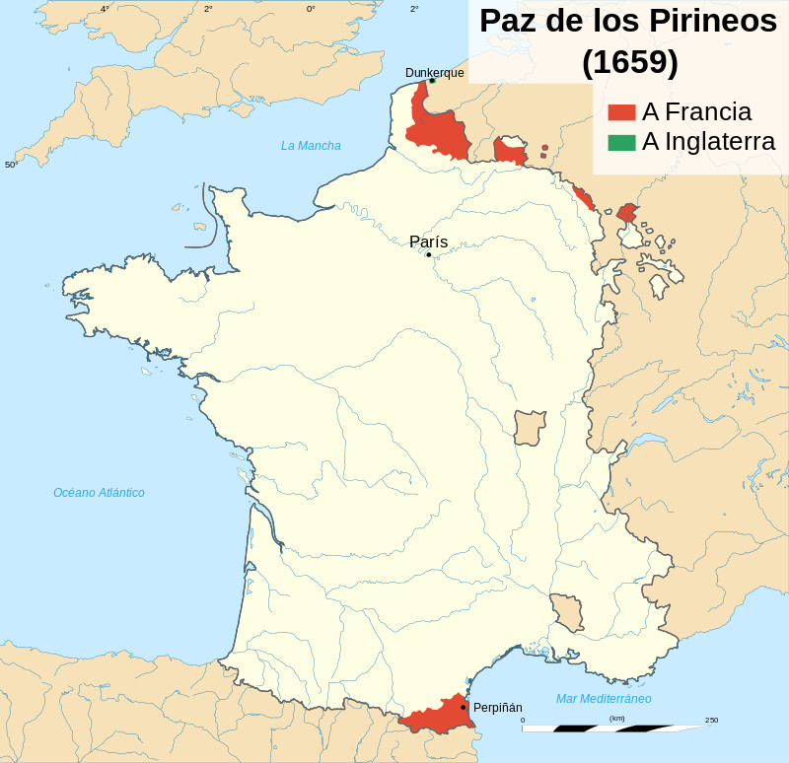
Did you know ... that the king in France was Louis XIII, married to the sister of Philip IV, Anne of Austria. His favourite was the Cardinal Richelieu.
These historical characters appeared in the novel “Los Mosqueteros”, written by Alexandre Dumas.
The war finished with the Peace of Westphalia (1648), in which Spain finally recognised the independence of The Netherlands.
Nevertheless the war between France and Spain continued till 1652. This conflict ended with the Treaty of the Pyrenees (1659) in which Roussillon (in the Pyrenees) and Artois (near Flanders) were given to France. In this treaty it was also arranged the marriage between the Spanish princess Maria Theresa and the future king Louis XIV, also known as the Sun king.

In 1640 there were popular uprisings in Andalusia, Catalonia and Portugal. These uprisings occurred because Olivares increased the taxes and asked for soldiers in order to support the war. All the effort to support the war was mainly made by Castile and Olivares tried to share the cost of the war, but the population protested and rejected this measure.
- In Andalusia the revolt was easily repressed.
- But Portugal managed to separate from the Spanish Monarchy.
- Catalonia received help from the French and the conflict continued till 1652.

Cultural and artistic legacy
Regarding to the cultural and artistic legacy we have to pay special attention to the period of Philip IV. He was educated with a special taste for arts and he was capable of seeing the special talent of Velázquez and appointed him as painter of the Court.
During his kingdom art and literature flourished with a special glory.
- In painting we have incredible artists such as Velázquez, Murillo, Zurbarán, Alonso Cano, Ribera...
- In sculpture we can still admire the works of Gregorio Fernández, Juan Martínez Montañés, Juan de Mesa and Alonso Cano. All these sculptures can be still enjoyed and admired during the processions of our “Semana Santa”
- In architecture The Madrid of the Austrias is recognised for its typical buildings such as the Town Hall (Ayuntamiento), “La Cárcel de Corte”, or the Gardens and Palaces of “Los Jardines del Buen Retiro”.
- In literature the importance of the legacy is undeniable and we can still read and enjoy the works of Lope de Vega, Quevedo and Góngora.

4.2. Charles II 1661 (1665) 1700
When Philip IV died Charles II was only 4 years old. Because of this the government was ruled by his mother Mariana of Austria, who ruled as a regent.
This kingdom was characterised by a general crisis and a weak government, caused by the serious health problems of Charles II.
In international relations the Spanish Monarchy started its decadence as a major power; this position was taken by France.
In 1700 Charles II died without an heir. In his testament Charles II appointed a candidate of the Bourbon dynasty as the next king of the Spanish Monarchy, this candidate was Philip of Bourbon. However Charles of Austria, appointed himself as the right candidate of the Spanish Monarchy.
Due to this confrontation the War of the Spanish Succession broke out. This war lasted till 1713 and ended with the Peace Treaty of Utrecht.
As a consequence of this Treaty the Habsburg dynasty finally disappeared in Spain and a new dynasty started, the Bourbon dynasty.
The Spanish Monarchy also lost all its European territories, and was displaced as a major power.
Did you know that....?
Due to the extreme consanguinity of the Habsburg marriages Charles II was physically and mentally disabled and infertile.
Marriages within the family by his ancestors led him to being almost as inbread as the child of an incestuous relationship.
His parents were uncle and niece and all of his eight great-grandparents were descendants of Joanna of Castile and Philip I.
Because of this inbreeding the Habsburg generation was more prone to still-births (miscarriages) than were peasants in Spanish villages.
It is said that Charles did not learn to speak until the age of four nor to walk until eight, and was treated virtually as an infant until he was ten years old. His jaw was so badly deformed (an extreme example of the so-called Habsburg jaw) that he could barely speak or chew.

