Unit 6 – Activities –
Modern States, the Catholic Monarchs and Geographical Discoveries

INDEX
2. The Creation of Modern States 1
1. Characteristics of Modern States 1
2. Some European Modern States 2
3. The Catholic Monarchs 3
3.1. The Unification of Castile and Aragon 3
3.2. The Creation of a Modern State 3
4. The Geographical Discoveries 6
4.1. Why did the discoveries start? 6
4.2. The Portuguese routes 6
4.3. The Castilian route 7
4.4. The Great Explorers and Navigators. 7
5. The Pre-Columbian Cultures 8

2. The Creation of Modern States

1. Characteristics of Modern States
- Say if the following characteristics of the Modern States are Right or Wrong. If they are wrong correct them.
  - A civil servant is a person that works only for the king and represents the interests of the monarchy. _____ _____________________________________
  - The meaning of civil servant in Spanish is: fuerzas del orden. ____ ___________________.
  - An example of Modern Army is “Los Tercios”. _____ _______________________.
  - “Los Tercios” were created by the emperor Carlos V, but their origin goes back to the Conquest of Granada during the kingdom of the Catholic Monarchs. _____ ____________.
  - The Nobility and the Monarchy worked together in the consolidation of the Modern State. ______ ________________________.
  - The Nobility confronted the Monarchy because they preferred a weak monarchy. ________ ________________________________________.
  - In Modern Times the Kings managed to limit and control the power of the Nobility. ______ ______________________________.
  - The Monarchs used the incomes from taxes in order to create a Modern Welfare State. _____ _________________________________.
  - In Modern Times religious minorities were tolerated. ______ _______________________.
  - A Diplomat is a person that represents the interests of the Crown inside the same country. _______ _____________________________.

2. Some European Modern States
- Say if the following characteristics of the Modern States are Right or Wrong. If they are wrong correct them.
  - All the kings of the Modern States mentioned in the unit suffered a weakening of their authority. ______ ____________________________.
  - Most of the kingdoms were divided and lost territories. ________ ____________________________________________.
  - Portugal started a period of maritime expansion. ______ ___________________________.
  - In Spain the Crowns of Castile and Aragon will be united thanks to the marriage of Isabel and Fernando, known as the Catholic Monarchs. _______ _____________________________.
  - A Tsar is like a king but with less power. ______ __________________________________.
  - In England the Tudor dynasty will be substituted by the Lancaster dynasty. _____ ________.
  - In France Kings will suffer a weakening of their power. _____ _________________________.
  - In Russia the Nobles will control the Tsars. _____ ___________________________________.

- Match correctly:
-France |  | - Henry VIII of the Tudor dynasty
-Spain |  | - Charles VII and Francis I of the Valois dynasty
-Portugal |  | - The Tsars Ivan the Great and Ivan the Terrible of the Rurik dynasty
-England |  | - Catholic Monarchs of the Trastámara Dynasty
-Russia |  | - John II of the House of Avis

3. The Catholic Monarchs

3.1. The Unification of Castile and Aragon
- Fill the gaps with the correct information.
Isabella and ________________ married in 1469. At that time they were not still _____________.
The kingdom of Isabella started in __________ and the kingdom of Fernando started in _______.
Isabella and Fernando were members of the same dynasty that is the House of ______________.
Their marriage implied a ________________ union, but not a ___________________ union. This means that both kingdoms kept their __________________, __________________, ________________ and ______________________.
However they shared a common ________________ _______________.

3.2. The Creation of a Modern State
- Write down the six new institutions created by the Catholic Monarchs in order to develop a Modern State:
- _________________________________________________________
- _________________________________________________________
- _________________________________________________________
- __________________________________________________________
- __________________________________________________________
- __________________________________________________________

- After the definition of each institution write the corresponding name:
- This institution was reorganised in order to increase incomes:
- They were people that represented the interests of the kings in the cities:
- It was a security force that imposed order in rural areas:
- They were a military force that worked only for the monarchy:
- They were institutions that helped the king to govern:
- Here the royal laws were applied:
- In the following map locate, draw and colour the territories conquered by the Catholic Monarchs and the corresponding dates.

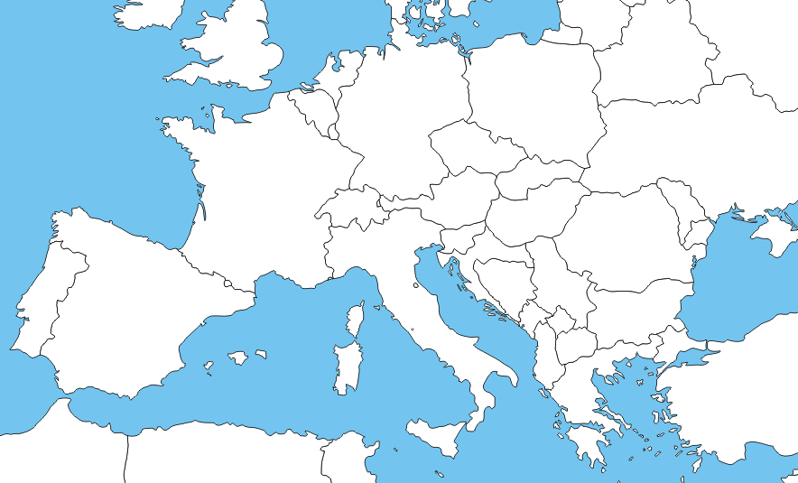

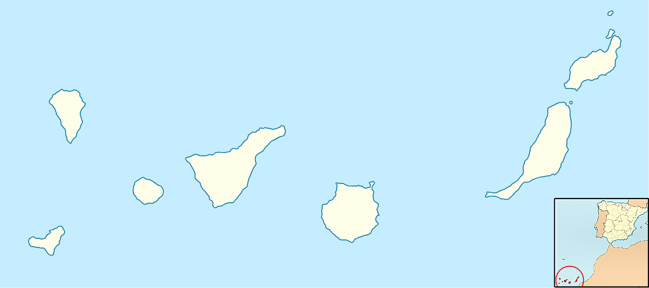

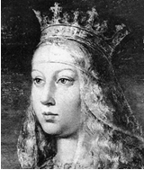

- Read the story of Isabella.
After reading the story fill the gaps of the family tree and answer the questions.

The unexpected Queen
Isabel was the daughter of Juan II and Isabel of Portugal (in his second marriage), the sister of Alfonso, and the half-sister of the king Enrique IV.
The king Enrique IV was married to Juana of Portugal and they had had a daughter called Doña Juana that would be the heir of the Crown of Castile.
During the kingdom of Enrique IV part of the Nobility confronted the king and proclaimed that Doña Juana was not the rightful heir because she was the daughter of the queen and don Beltrán de la Cueva, who was the favourite of the king.
The Nobility that was against the king chose Alfonso (brother as Isabella) as the rightful candidate to the crown, but he died in 1468 in strange circumstances.
The Nobility decided then to support Isabel as the best successor of Enrique IV. After many conflicts and discussions Enrique IV recognised Isabel as the princess of Castile instead of his own daughter Doña Juana. This decision was written in the Treaty of the Bulls of Guisando.
After the death of Enrique IV some nobles supported Doña Juana and some nobles supported Isabel and a War of Succession started (1475-1479).
Finally the conflict was won by the supporters of Isabel and she will reign in Castile till his death in 1504.
- Fill the gaps of this family tree
First Marriage
Second Marriage

Juan II de Castilla
Isabel de Portugal
María de Aragón

Isabel
_____________
Enrique IV
Dª Juana de Portugal

________________________

- Answer to the following questions:
  - When did Alfonso, the half-brother of Enrique IV, die? ___________________
  - Why were Isabel and Alfonso half-sister and half-brother of Enrique IV?
__________________________________________________________________________________________________________________________________________________________
_____________________________________________________________________________
  - With what Treaty did Enrique recognised Isabel as the heir of the Crown of Castile? .
  - Why do you think that Doña Juana was called “La Beltraneja?
__________________________________________________________________________________________________________________________________________________________
  - Who did the nobility support first, Alfonso or Isabel?______________________
  - What happened when Enrique IV died? _____________________________________
_____________________________________________________________________________
_____________________________________________________________________________
  - When did Isabel die? _______________________

4. The Geographical Discoveries

4.1. Why did the discoveries start?
- Read the text and change the words that are wrong by right words (write the correct answer above the wrong one).
The Seleucid Turks conquered Constantinople in 1492. Because of this the Silk Road was controlled by them. Thanks to the Silk Road wool, amber and other products came from Asia.
- What innovations were essential for the beginning of the maritime explorations?
- -
- -
- -

4.2. The Portuguese routes
- Answer correctly to these questions:
  - In the African phase they will sail along the ______________________.
  - The first steps will be ________________________________
  - Later they will arrive to the _____________________________
  - And _________________________ will discover __________________________
  - In _____________________
  - In the Indian phase Vasco de Gama will arrive to ____________ in ____________, to the port of ______________________

4.3. The Castilian route
- Say if the following sentences are Right or Wrong
  - Columbus knew that between Europe and Asia there was a continent. _______
  - The best friend of Columbus was Amerigo Vespucci and he called the new continent America in his honour. ______________
  - Columbus only presented his project to the Catholic monarchs ___________
  - Nobody knew that the Earth was round and that was the great discovery of Columbus ____________
  - Columbus was from the city of Valencia ____________
  - The Queen Isabella didn’t accept to finance the expedition of Columbus. _____
  - Columbus thought that he had arrived to Japan (Cipan-go). ________
  - Columbus made five expeditions in total. ___________
  - With the Treaty of Tordesillas the discovered territories will be divided between Castile, Portugal, England and France. _____________
  - With the Treaty of Tordesillas the discovered territories will be divided between Castile and Portugal. _____________
  - Castile will control America, The Philippines and Brazil. _______________
  - Portugal will control Brazil, Africa and India. __________________

4.4. The Great Explorers and Navigators.
- Write down the name of the corresponding explorer:
  - In 1513 he crossed the Isthmus of Panama and discovered a new ocean, the Pacific Ocean. In this way it was confirmed that America was a new continent. ________________________
  - They circumnavigated the Earth for the first time (1519 – 1522). ____________________________________________
  - He was the first person that affirmed that the new discovered territories were in fact a new continent (1503). ___________________________
  - He led the first expedition to La Florida in 1513. _________________________

5. The Pre-Columbian Cultures

- Match correctly.

Mayas |  | Valley of Mexico
Aztecs |  | High Plateaus of the Andes
Incas |  | Central America

- Tell me what civilization corresponds to the characteristic that is mentioned. (Sometimes you may have to write two or three cultures).
  - They were polytheists. ____________________
  - The emperor was the most important person. _____________________
  - They had advanced knowledge of astronomy. ______________________
  - They had an advanced calendar. _____________________________
  - They were in decline when the Spaniards arrived. ____________________
  - They built a very impressive network of roads. ________________________
  - They had their own writing system. _____________________________

- Fill the column with the products that America and Europe will provide to each other.
America will provide | Europe will provide

Favourite: is a personal counsellor of the King. The Spanish name is valido.
Tratado de los Toros de Guisando.

