Unit 6 - Modern States - The Catholic Monarchs and the Geographical Discoveries.

INDEX
1. A Short Introduction 2
2. The creation of Modern States 2
2.1. Characteristics of Modern States 2
2.2. Some European Modern States 2
3. The Catholic Monarchs 3
3.1. The Unification of Castile and Aragon. 3
3.2. Creation of a Modern State. 3
a) New Institutions 3
b) Territorial expansion and unification 3
c) Religious unification. 4
4. The Geographical Discoveries 4
4.1. Why did the discoveries start? 4
4.2. The Portuguese routes. 5
4.3. The Castilian route. 6
a) Columbus’s Project 6
b) Columbus’s Expeditions 6
c) Consequences: rivalry between Castile and Portugal. 6
4.4. The Great Explorers and Navigators 7
5. The Pre-Columbian Cultures 8
a. The Mayas 8
b. The Aztecs 8
c. The Incas 9
d. Transformations and exchanges 9

A Short Introduction
During Modern Times we observe how Modern States are being created. This Modern State has specific characteristics that we will study that we will study in this unit. One example of these Modern States is the kingdom of the Catholic Monarchs.
The Geographical Discoveries are also important because they mark the entrance in Modern Times as it implied a deeper knowledge of the world and a change in mentality that was the end of a superstitious and medieval mentality and the beginning of a practical and more modern concept of the world.
During the kingdom of the Catholic Monarchs the discovery of America will take place; it will imply the contact with unknown civilizations and an intercultural exchange.

The creation of Modern States

Characteristics of Modern States
In the 15th century Modern States were created all over Europe. They have some similar characteristics that make them different from Middle Ages.
- They organised centralised administrations with civil servants that worked for the kings.
- They created professional and modern armies that were loyal to the kings.
- They controlled the power of Nobility.
- They limited the power of representative assemblies (Parliaments or Cortes).
- They increased taxes in order to pay a modern army and central administration.
- They promoted a territorial unification, with marriages or military campaigns.
- They imposed a religious unification, with the creation of the Inquisition, repressive laws and expulsions.
- They created a diplomatic service where ambassadors could defend the interests of the Crown in foreign territories.

Some European Modern States
During the 15th centuries European monarchs managed to create Modern States all over Europe. Here you have some examples:
- France. Kings managed to consolidate their power and unify their territory.
- Spain. With the kingdom of the Catholic Monarch the Modern State will be established in Castile and Aragon.
- Portugal. Also in Portugal the monarchy will manage to impose its authority. They will be able to start the geographical explorations and discover a new route to Africa and Asia.
- England. The Tudor dynasty will reinforce its royal power.
- Russia. The Tsars (emperors) will be able to increase their power, control the nobility and conquer new territories.

The Catholic Monarchs

The Unification of Castile and Aragon.
Isabella and Ferdinand married in 1469. When they were married they were not monarchs yet.
After many conflicts, confrontations and a civil war their rule began in 1474 and 1479 respectively.
Thanks to this marriage the Crowns of Castile and Aragon were united although not unified because each crown maintained its own frontiers, laws, institutions and independence (in internal affairs). However both kingdoms shared a common foreign policy.
It was a dynastic union, not a territorial union and that means that every kingdom kept its laws, institutions, borders and independence.

Creation of a Modern State.
Once their rule began they started a process of modernisation and reinforcement of their power and authority. It included territorial unification, religious unification and creation of new institutions.

New Institutions
The creation of these new institutions had the only intention of creating a powerful and centralised administration that could reinforce the power of the kings.
- The Holy Brotherhood (Santa Hermandad) that was a security force that imposed order in the rural areas.
- Permanent and professional army.
- Courts of Justice (chancillerías), that will apply royal laws.
- Corregidores that were institutional representatives of the kings in the cities.
- Royal Councils (Consejos) that helped the kings to govern.
- They reorganised the Royal Treasury (Hacienda Real) in order to increase their incomes.

Territorial expansion and unification
The Catholic Monarch will conquer new territories inside and outside the Iberian Peninsula in order to increase their power.
- Granada was conquered in 1492 and annexed to the Crown of Castile. Granada was the last Muslim territory and this conquest will mean the end of the Reconquest.
- In North Africa they conquered Melilla, Oran and Bougie. (1497, 1509 and 1510 respectively).
- They conquered the Canary Islands (1496).
- They incorporated the kingdom of Naples in 1504 and annexed it to the Crown of Aragon.
- They conquered the kingdom of Navarre in 1512 and annexed it to the Crown of Castile.
- They also organised a brilliant marriage policy that established alliances with other European monarchs.

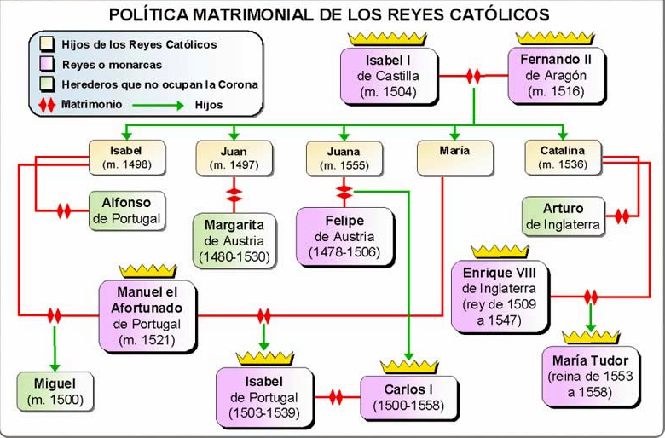

Religious unification.
Although in the Iberian Peninsula existed three different religions practiced since medieval times the Catholic monarchs imposed a religious unification.
In this way they created the Spanish Inquisition in 1478; in 1492 they expelled the Jews if they didn’t convert to Christianity and in 1502 the expelled the Muslims that didn’t convert to Christianity.

4. The Geographical Discoveries

Why did the discoveries start?
Due to the conquest of Constantinople by the Ottoman Turks in 1453 the traditional Silk Road that connected Asia with Europe was controlled now by the Turks.

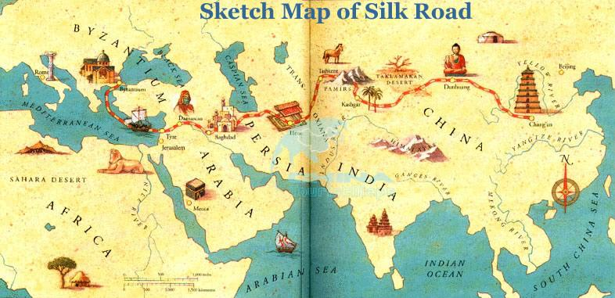
The Silk Road was a trading route that connected Asia with Europe. Traders brought silk, species and other products from Asia.

The Europeans will start looking for other routes that could connect Europe and Asia without crossing the territories controlled by the Ottoman Empire; these routes will be mainly maritime routes.
Some innovations were essential for the start of the maritime voyages:
- The improvement of portolan charts that are navigational maps.
- The changes in the caravel that made this ship a perfect option for sailing long distances.
- The spread of navigational tools such as the astrolabe (Greek and Arab origin), the quadrant, the compass (Chinese origin) and the rudder.
There were two main kingdoms that concentrated the process of discoveries, Portugal that will follow the African route and Castile that will follow the Atlantic and American route.

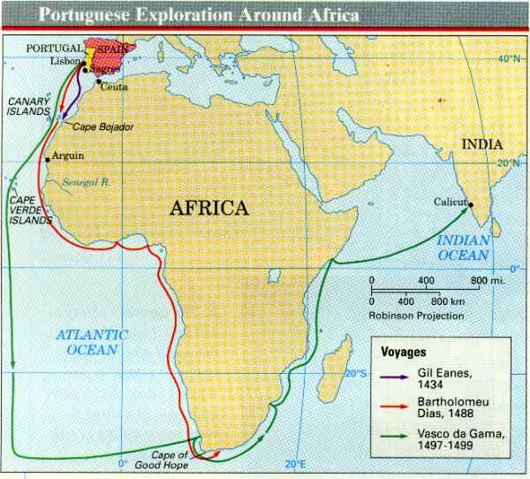
The Portuguese routes.
The Portuguese will sail across the Atlantic Ocean along the African Coast with the intention of reaching India.
There are two phases:
- The African phase. In this period they will sail all along the western African coast. The first steps will be Madeira and Azores, later they will arrive to the Gulf of Guinea and finally Bartolomé Dias will discover the Cape of Good Hope in 1488.
After the discovery of the Cape of Good Hope the Portuguese will enter into the Indian Ocean and will be closer to their final objective.
- The Indian phase. Vasco da Gama will arrive to India in 1498, to the port of Calicut. In this way the route to India was discovered and controlled by Portugal.
From now on Portugal will exploit as a monopoly the trade of silk and spices in Europe.
Portugal will create an extensive maritime empire that will include Brazil in 1500 after being discovered by Pedro Álvares Cabral.

The Castilian route.

Columbus’s Project
The Castilian route was based on Columbus’s project. He wanted to reach the Spice Island sailing westwards through the Atlantic Ocean. In his project Columbus affirmed that the Earth was round and smaller. In addition he didn’t know that there was a continent on his way to Asia that later will be called America.
Columbus presented his project to the King of Portugal, but he rejected it as Portugal had already discovered the route to Asia through the Indian Ocean.
After this rejection he presented his project to the Catholic Monarchs and Queen Isabella accepted to finance his expedition and signed the Capitulations of Santa Fe in 1492.

Columbus’s Expeditions
- The first expedition of Columbus departed from the port of Palos de la Frontera (province of Huelva) on 3rd August 1492. The expedition was formed by the three famous sailing ships the Pinta, the Niña (both caravels) and the Santa Maria (a nao).
On the 12th October 1492 Columbus arrived to an island in the Bahamas that he will call San Salvador. In this travel they explored the nearby islands and Cuba and Haiti.
Columbus thought that he had arrived to the coasts of Cipan-guo (Japan).
- Columbus made three more expeditions and he explored and discovered the islands of the Caribbean Sea and the coasts of Central and South America.
When Columbus died he still was convinced that he had reached the coasts of Asia. In the end Amerigo Vespucci, an Italian navigator, will prove that the discovered lands were in reality a new continent. Because of this the new continent will be named America.

Consequences: rivalry between Castile and Portugal.
Castile and Portugal will try to control and monopolise the discovered territories and sailing routes. This will cause tensions and problems between both crowns.
In order to avoid problems they signed an international treaty called the Treaty of Tordesillas (1494) in which the Pope mediated between both crowns.
This treaty divided the Earth in two areas of influence. The line that separated these two areas was a meridian that was 2000 kilometres west of Cape Verde Islands. All the territories at the West of that line will belong to Castile (America and the Philippines) and all the territories at the East of that line will belong to Portugal (Africa, India and Brazil).
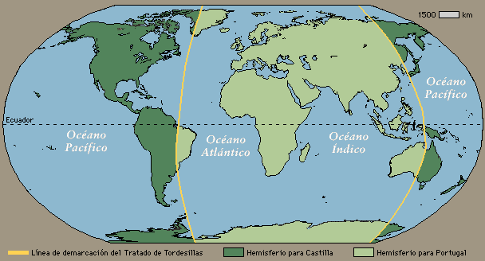

The Great Explorers and Navigators
Apart from the already mentioned Bartolomé Dias, Vasco da Gama and Columbus there were other explorers and navigators whose discoveries were so important that they will change for ever the vision and perception of the world.
Here you have some of them:
- Amerigo Vespucci. He was an Italian trader and cosmographer that established and worked in Castile. He was the first person that affirmed that the new discovered territories were in fact a new continent (1503). Because of this the new continent was named America in his honour.
- Vasco Núñez de Balboa. In 1513 he crossed the Isthmus of Panama and discovered a new ocean, the Pacific Ocean. In this way it was confirmed that America was a new continent.
- Juan Ponce de León led the first expedition to La Florida in 1513.
- Ferdinand Magellan and Sebastian Elcano. They circumnavigated the Earth for the first time. The expedition departed from Sanlúcar de Barrameda in Seville in 1519 commanded by Magellan. They crossed the Atlantic Ocean till they arrived at South America. There they discovered the Strait of Magellan and continued through the Pacific Ocean. Then they reached the Mariana Islands and the Philippines (they were the first Europeans that visited those islands). Magellan died in the Philippines and Sebastian Elcano took control of the expedition and continued the voyage arriving to Seville on 1522.
  - The expedition lasted three years and only one ship and 18 seamen finished the voyage (5 ships and 234 seamen had departed from Seville).
  - The importance of this expedition is undeniable as it was the first voyage around the world, it demonstrated that the Earth was round; they calculated the diameter of the Earth and discovered new territories for the Crown of Castile.
- Álvar Núñez Cabeza de Vaca, who during 1520-1540 explored Florida, Alabama, Mississippi, Louisiana, Texas, New Mexico, Arizona, Northern part of Mexico and the gulf of California. These territories will be annexed to the possessions of Charles I.
- Other explorers were Francisco Vázquez de Coronado, Hernando de Soto, Alonso Álvarez de Pineda, Juan de Oñate, Lucas Vázquez de Ayllón, Juan Rodríguez Cabrillo and Estebanico (among others).

The Pre-Columbian Cultures
The discovery of America will also mean the discovery of new cultures and advanced civilisations.
These civilisations were the Mayas, the Aztecs and the Incas.
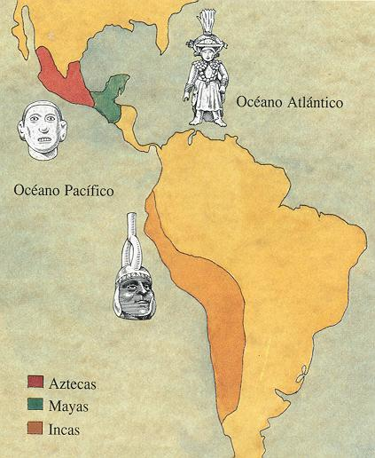

The Mayas
The Mayas lived in Central America. This civilisation was in decline when the Spaniards arrived. They were divided in independent city-states, their main economic activity was agriculture, but they were also excellent traders. They were polytheists, they also had advanced knowledge of astronomy (they made calendars) and developed writing.
Their typical constructions were palaces and temples; the temples are beautiful stepped pyramids that were used for sacrifices and also for astronomical observations.

The Aztecs
The Aztecs lived in the valley of Mexico where they created a great empire. The emperor had absolute political and religious power. They were a culture of warriors and conquerors.
Their society was very hierarchical and was divided in different groups (warriors, priests, merchants, craftsmen, peasants and slaves).
The most important economic activity was agriculture and they developed very advanced agricultural methods (they could have seven crops per year).
They built cities, palaces and temples in the form of stepped pyramids. The capital city of its empire was Tenochtitlan. They also had astronomical knowledge (they created an advanced calendar) and they had their own writing system.
They believed in many gods and made human sacrifices.

The Incas
They lived in the high plateaus of the Andes; their territories correspond to nowadays Peru, Bolivia, Ecuador, part of Argentina and part of Chile.
The emperor was the Inca, who was believed to be the son of the Sun.
The society was organised in different social groups (nobles, peasants, craftsmen and slaves).
They were also polytheists.
They built temples, palaces, fortresses (like Machu Pichu) and a very advanced network of roads.

Transformations and exchanges
The new territories will be considered property of the Crown of Castile that will organise its exploitation in order to obtain benefits.
The form of exploitation will be called “encomienda”, thanks to which the colonisers received land and indigenous people. In exchange for working the land the local people will receive instruction in the Christian faith, instruction in the Spanish language, protection, food and shelter.
Of great importance was an interesting process of mixing ethnic groups called “mestizaje”. It created a system of classification depending on the origin of your ancestors.
An important contribution was the exchange of products, crops and techniques between the two continents.
- In this way America will provide new products such as tomatoes, potatoes, maize, cocoa, pineapple.
- While Europe will provide horses, cattle, hens, wheat, plough….


In Spanish they are called Cartas Portulanas.
Rudder: tool or gadget for steering a ship. (Timón).

