Unit 5 – Activities - Modern Times.

INDEX
1. A Short Introduction 1
2. Humanism 2
2.3. The Printing Press 3
3. The Reformation and the Counter-Reformation 4
3.1. Origin, causes and consequences of the Reformation 4
3.2. The Catholic Counter-Reformation 6
4. The Renaissance and Flemish painting 7

A Short Introduction
- In what centuries does Modern Times take place?

- What is the most important event that marks the beginning of Modern Times?

- What are the characteristics of Modern Times?
- -
- -
- -
- -
- -

- Math correctly the following concepts:
- 16th century - Enlightenment
- 17th century - Renaissance
- 18th century - Baroque

Humanism
- What is Humanism?

- What are the characteristics of Humanism?
- -
- -
- -
- -
- After reading the characteristics of all the humanist philosophers that are mentioned in the text which one do you prefer? Explain why.

- Choose one humanist and research a little bit about him (or her) and explain to the class what you have learned.

- In this activity you are going to read some ideas and you will have to tell to what area they correspond. There are two ideas for each area.
Here are the areas: Defence of the Amerindians (Francisco de Vitoria), International Law, Natural Law and Economy.

- Neither the Pope, nor Charles V have a rightful claim over Indian lives or property. ___________________________
- The entrance of silver and gold without control caused rise of prices (inflation) and affected the poorest social groups. _____________________________________
- The common good of the world is of a category superior to the good of each state. __________________________
- The relation between states should be justified by law and justice, and not justified by force. _______________________________
- The people are the vehicle of divine sovereignty, which they, in turn, pass it to a prince. ___________________
- There were limits on the legitimate powers of the government. _________________________
- Private property and competitiveness are positive for the development of trade. __________________________
- No violent action could be taken against the Indians, nor could their lands or property be seized. _______________________________

The Printing Press
- Fill the gaps with the correct word.
Words for the gaps: Mainz, invention, movable types, goldsmith.
- The printing press was an _________________ created by Gutenberg in 1450. Gutenberg worked as a ___________________ in the city of ________________. He didn’t really invent the system of printing, but he improved it with the creation of _________________________ that gave to the printing press a tremendous efficiency. He also created a special ink and the printing press itself. All these innovations conferred to the printing press a great potential and the capacity of printing thousands of copies in no time.
- Here you have ideas and characteristics that you have to place in the correct place (write only the numbers) :

  - Pre-Gutenberg society:
  - Post-Gutenberg society:
- Critical thinking  - Illiterate  - Schools  - Gutenberg Bible  - Oral culture  - Nationalism  - Common people had access to information  - Few books and most in Latin  - Priests would announce news at the church.  - Contradictions among texts | - Schools  - Large number of books  - Feudal society  - Spread of Humanism and scientific ideas  - No schools, except for elites  - People could be informed more easily  - Questioning of authority  - Modern society  - Information controlled by Church and aristocracy  - Creation of grammars and consolidation of national languages.  - Literacy (ability to read and write)

The Reformation and the Counter-Reformation

3.1. Origin, causes and consequences of the Reformation
- Why Martin Luther was not happy with the Catholic Church?

- Math the following religions with the corresponding territory where they were practiced.
Lutherans  Calvinists  Puritans  Huguenots  Anglicans |  | Switzerland  Scandinavia  Low Countries  France  Some German States  England  Scotland

- Locate in the correct place inside the map or with arrows the following religions:
Lutherans, Catholics, Calvinists, Puritans, Huguenots, Anglicans.
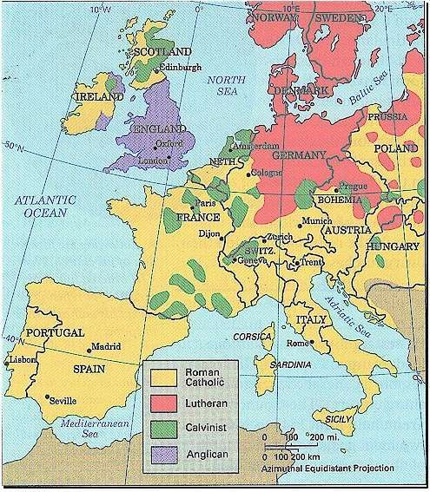

- Fill the gaps with the correct word.
Words for filling the gaps: Scotland, Calvino, France, Henry VIII, Switzerland, Anglicanism, Scandinavia.
- Calvinism was a protestant religion founded by ____________ in ______________. Other religions evolved from Calvinism that is the case of the Puritans that was followed in _______________ and the Huguenots that lived in ________________.
- The Lutherans expanded to ______________ that is formed by (Denmark, Norway, Sweden and Finland).
- At the same time in England _______________ put into practice his own protestant religion that is called __________________. In this religion the leader of the Church is the king and not the Pope.

3.2. The Catholic Counter-Reformation
- Put these characteristics in the correct column.
(Write all the information and with good handwriting, it may be helpful for studying).
- Obedience to the Pope. // - Negation of the figure of the Pope.
- Clergy can get married. // - Celibacy among clergy.
- Seven Sacraments (baptism, Eucharist, confession, confirmation, marriage, ordination, anointing of the sick). // - Only two sacraments.
- Any person can interpret the Bible. // - Only the clergy can interpret the Bible.
- The Virgin and the Saints can be worshipped. // - Negation of the sanctity of the Virgin and the Saints.
- Salvation only through faith. // - Salvation through faith and good acts.
- Austere religion ceremonies. // - Lavish religious ceremonies
- Churches with altars and profusion of images. // - Churches without altars and images.
Protestantism | Catholic Church

The Renaissance and Flemish painting
- Say if the following statements about Renaissance are True or False and write the correct information if they are wrong.
  - Renaissance was inspired by Gothic art. ______ _______________________________
  - They used the classical orders that are Doric, Ionic and Corinthian. ______ __________
  - They used hierarchical perspective. ________ _________________________________
  - Importance of God that is the model that must be copied. _________ _____________
______________________________________________________________________
- Place the following terms in the correct column. If the term can be in more than one column repeat the term as many times as you need.
Donatello, Leonardo de Vinci, Titian, Michelangelo, Brunelleschi, Pierro della Francesca, Raphael Sanzio, Bramante, Masaccio, Mantegna, Palladio.

Quattrocento | Cinquecento
- Place the following terms in the correct column. If the term can be in more than one column repeat the term as many times as you need.
Donatello, Leonardo de Vinci, Titian, Michelangelo, Brunelleschi, Pierro della Francesca, Raphael Sanzio, Bramante, Masaccio, Mantegna, Palladio.

Architecture | Painting | Sculpture
- Fill the gap with the correct information:
  - Donatello was an sculptor, some of his works of art are _________________________
______________________________________________________________________.
  - “The Birth of Venus” was painted by _____________________.
  - Masaccio, Pierro della Francesca, Mantegna and Botticelli were __________________.
  - Bruenelleschi was an _____________________ and he constructed the ____________
_________________________________.
  - Michelangelo painted the ceiling of the ____________________________ that is located in the Vatican.
  - Leonardo da Vinci was called a ___________________________ because he controlled many areas of knowledge.
  - One of the most famous works of art of Leonardo is ____________________________.
  - Bramante was and ______________________ that worked in ___________. His famous Tempietto of San Pietro in Montorio was paid by the Catholic Monarchs.
  - Palladio was an ______________________ that worked in ________________. He created very elegant and stylish palaces.
  - Raphael worked for the Popes of Rome and decorated the _______________________
______________________________________________________________________.
  - Titian was an excellent painter that worked in _______________, he was very appreciated by ________________________________________.
- Write down the characteristics of Flemish painting:
- Influenced by __________________________________________
- .
- .
- .
- Topics: _____________________________________________________
- Artists:

Goldsmith: joyero
Celibacy: celibato. Abstention from marriage.
Lavish: opulent, rich, generous.

