Activities - The Tertiary Sector by Gema de la Torre is licensed under a
Creative Commons Reconocimiento-NoComercial 4.0 Internacional License
Unit 4 – Activities - The Tertiary Sector
INDEX
1. Introduction 1
2. Economic Inequalities in the Tertiary Sector 1
3. Tourism 2
4. Transport 2
6. Trade 3

Introduction
- Think about one product that you have in your house or in your room and make a list with all the industrial and service processes that have taken place so that you can have that product in your house.



Economic Inequalities in the Tertiary Sector
- Think about two countries, one developed and the other underdeveloped, and look for the rates in the CIA Factbook:

Tertiary Sector | ______ | ______
Part of the GDP:
Labour Force:
- Tell me some characteristics of the tertiary jobs in the underdeveloped country:

Tourism
- Choose one topic and research in groups of four
  - Impact of tourism to local people in the city of Barcelona.
  - How the city of Benidorm has been transformed due to tourist activities.
  - How the city of Peñíscola has been transformed due to tourist activities.
  - Why are the meadows of Posidonia of the sea floor of Ibiza threatened? Why are the meadows of Posidonia so important?
  - How is mass tourism affecting daily life in Venice and how can we transform this mass tourism into a sustainable tourism?
  - What are the Pros and Cons of tourism in Madrid? Mention as many examples as possible.
  - Is skiing an environmental tourist activity? Explain your opinion with information.
  - Explain the problem of the Hotel “El Algarrobico”, constructed in the Natural Park of Cabo de Gata-Nijar (Almería) and now declared illegal.

Transport
- Compare these two transport networks.
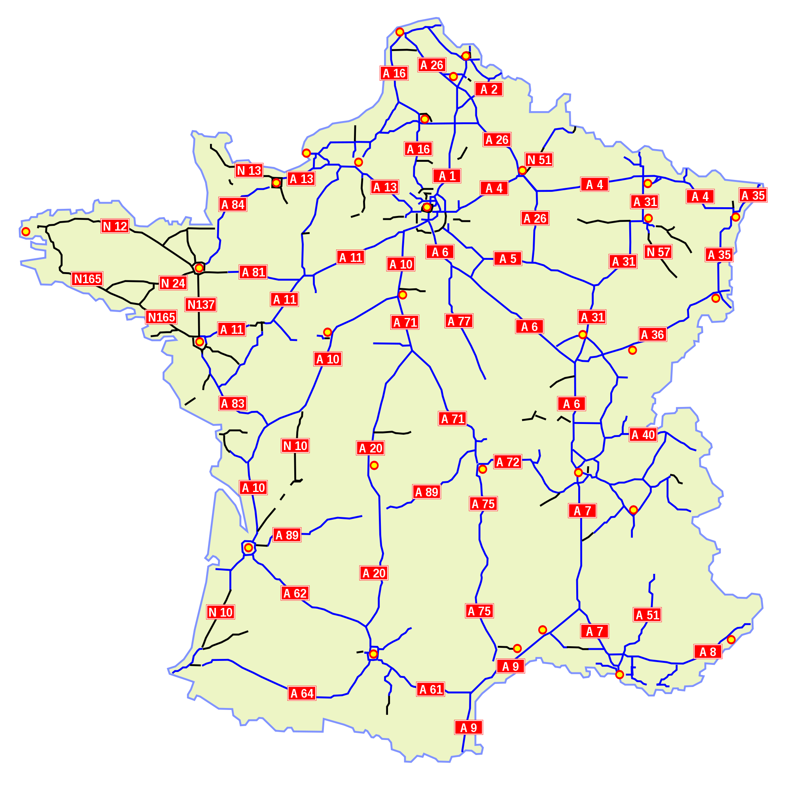
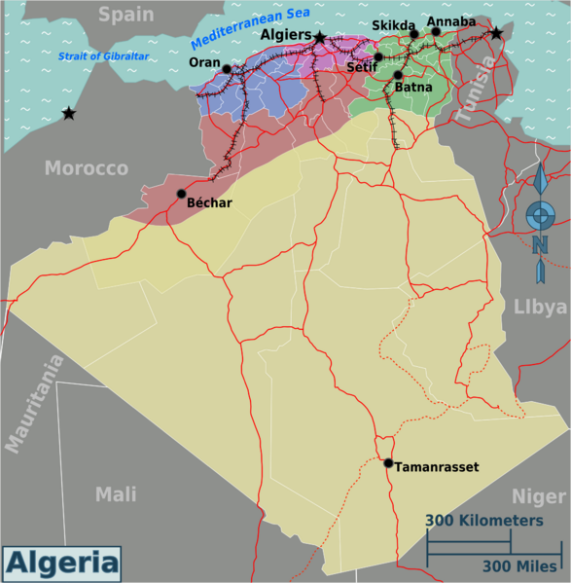
  - First explain what you see, the main differences and later deduce more characteristics (the ones that you cannot see…)
Road network of France
Road network of Algeria

- Research and explain what is the meaning of the following terms:
Clue: they refer to the different costs of transport and who has to pay each cost the seller, or the buyer. Every product that is transported includes one incoterm and they appear in every invoice of an international transport. Some of these costs are inner transport, insurance, customs clearance (aduana), taxes and transport at the port, international transport of freight, taxes and transport at destiny port, customs clearance at destiny and inner transport at destiny.
  - Incoterms

  - EXW (Exworks)

  - FOB

  - CIF

  - DDP

  - DDU

- In the following diagram put each incoterm in the exact place.

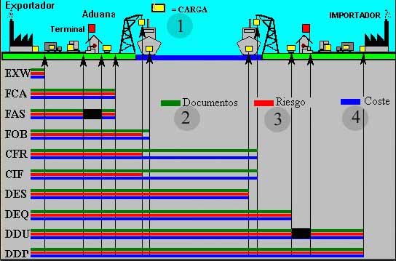

- What type of transport would you choose for the following goods:
Watches from another country
Cars from one province to another province
Flowers, seafood… perishable goods in general
Small packages inside one city
Small packages from one city to other
Concrete (hormigón) structures of huge dimensions

Trade
- Research about the TTIP. What are its main controversies, why do people protest about it…?

- Pay attention to the following cartoon. What is it criticizing? What information can you deduce from the cartoon?

