Unit 3 – The Secondary Sector
INDEX
1. Introduction 2
1.1. What is Secondary Sector? 2
1.2. What are industry, mining, energy production and construction? 2
2. Origin of raw materials 2
3. Sources of energy 2
3.1. Traditional sources of energy 2
3.2. Alternative or renewable sources of energy 3
4. Industrial regions and Economic inequalities 3
4.1. Industrial regions 3
a) United States, Japan and the European Union. 3
b) Some regional powers. 3
c) Emerging countries. 3
d) Less industrialised countries. 3
4.2. Economic Inequalities 3
5. Types of Industries 4
5.1. Taxonomies 4
5.2. Basic Industries (Characteristics, Location and Examples) 5
5.3. Capital Goods Industries 5
5.4. Consumer Goods Industries 6
5.5. High-Technology Industries 7
6. Environmental problems 7
7. Industry in Europe and Spain 8
7.1. Types of industries 8
a) Traditional industries 8
b) Dynamic industrial sectors. 8
c) High-Technology industries 8
7.2. The industrial regions in Spain 8
7.3. Some examples of Spanish Industries 8
7.4. Problems and challenges in Spanish industry 9
7.5. Some Data 9

Introduction

What is Secondary Sector?
The secondary sector refers to the economic activities that transform raw materials into manufactured products. These economic activities are industry, mining, energy production and construction.

What are industry, mining, energy production and construction?
All of them are economic activities that belong to the secondary sector.
- Industry: transforms raw materials into finished products or semi-finished products.
- Mining: is the process of locating, extracting and refining the rocks and minerals that are in the ground.
- Energy production: is the process of transforming different types of fuel (gas, oil, coal or renewable sources of energy) into forms of energy.
- Construction: creates structures such as buildings and infrastructures such as dams, roads, bridges, canals…

Origin of raw materials
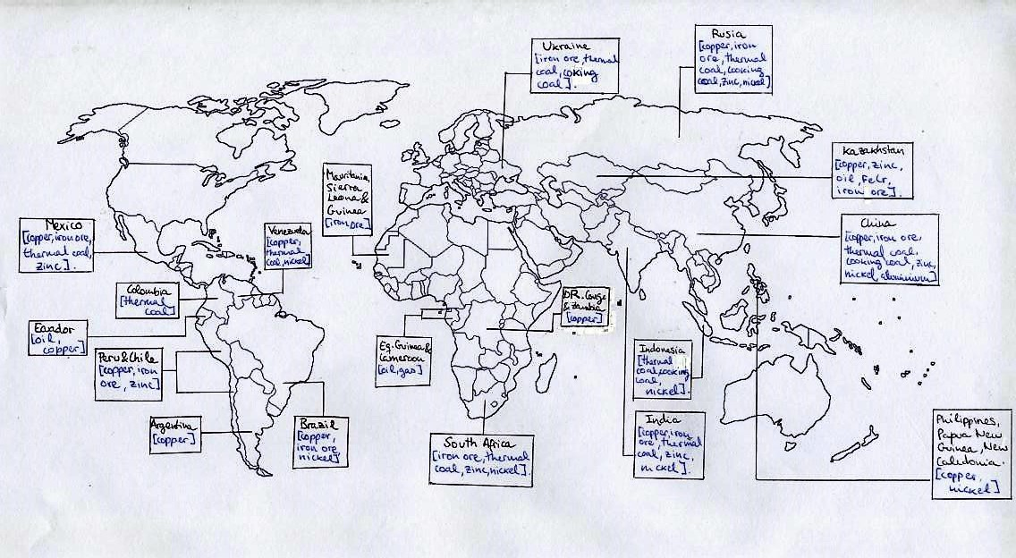

Sources of energy
There are two types of sources of energy: traditional and alternative

3.1. Traditional sources of energy
Here we can find the energy that comes from coal, oil, natural gas and nuclear fuels.
These resources are non-renewable energies and in the future they will be exhausted.
Here we can also find the hydroelectric energy that is a renewable energy. It is included in this group because it is used by industry and because its infrastructures usually imply a great environmental impact.
Oil is the most common source of energy (41%), natural gas is the next one (23%), coal (22%), Hydroelectric (7%) and nuclear (7%).

3.2. Alternative or renewable sources of energy
They pollute less and cannot be exhausted. Some examples are solar energy, wind power, biomass and geothermal energy.

Industrial regions and Economic inequalities

Industrial regions
United States, Japan and the European Union.  Here we can find the most modern and advanced industries. They invest great amounts of money in R and D (Research and Development). They also can enjoy large markets for their products with citizens with a high economic level. | Some regional powers.  Some examples are Russia, Australia, New Zealand, South Africa and the oil exporting countries.  These countries have high levels of industrialization and are a reference in their region.
Emerging countries.  These are countries that have undergone a recent process of industrialization. The percentage of industry is increasing and also the quality and modernisation of that industry.  In Asia some countries are China, South Korea, India, and Taiwan. In Latin America we can find Brazil and Mexico. | Less industrialised countries.  Here we can find countries with a very low percentage of secondary sector and also with an outdated and old industry. They have a lack of investment, transport, infrastructures and demand; all these characteristics restrain any process of further industrialization.

4.2. Economic Inequalities
As we have already seen the world is divided in different industrial areas. Here we will try to explain why this difference exists.
Developed Countries
- High investment in Research and Development.
- Advanced and modern technology (computers, software, robots…)
- Access to large markets with a high demand (due to the high economic level)
- Very competitive
- They buy raw materials (that are usually cheap) and sell manufactured products (with a high value added –alto valor añadido) (cars, machinery, computers…)
- Positive Commercial Balance
- Green sources of energy
- Industries more respectful with the environment

Emerging Countries
- Foreign investment (the industries are constructed by multinationals that take advantage of cheap labour and the new markets).
- Modern technology (but controlled by foreign industries).
- Most of the profits go to foreign countries (the ones that made the investment).
- Cheap labour and low salaries
- Increasing market, but still not very structured and with a low demand.
- Investment in infrastructures.
- Technology less respectful with the environment.
- Positive Commercial Balance

Underdeveloped Countries
- Lack of investment in Research and Development
- Lack of infrastructures, transport and capitals.
- No internal market.
- Traditional and outdated industries
- Not competitive
- Most of the industries are related to the extraction of minerals and raw materials.
- Highly-polluting industries.
- Negative Commercial Balance (as they sell cheap raw materials and few but expensive manufactured products)
- Vicious circle of poverty.

Types of Industries

Taxonomies
Taxonomy is a type of classification according to different characteristics. As there are many types of industries were are going to classify them in different taxonomies (or groups).

According to dimensions and the consumption of energy | Heavy industry: large dimensions, they consume large amounts of raw materials and energy; they pollute a lot.
According to dimensions and the consumption of energy | Light industry: small dimensions, they consume less raw materials and energy; they pollute less.

According to the final products | Basic Industries: they produce semi-finished products for other industries.
According to the final products | Capital Goods Industries: they produce finished products but for other industries.
According to the final products | Consumer Goods industries: they produce finished products for the consumers.

According to the technology | Traditional Industries
According to the technology | New Industries
According to the technology | High-Technology Industries

Basic Industries (Characteristics, Location and Examples)
- Characteristics
In Spanish they are called “Industrias de Base”
They are also called: Traditional Industries or Heavy Industries
They consume large amounts of raw materials and energy (Note: They are called Heavy Industry because of this).
Basic industry manufactures raw materials into semi-finished products. (Note: Semi-finished products are products that will be used by other industries, such as Steel sheets, Copper Coils, bulk chemical such as ammonia, sulphuric acid, food additives…)
They have big dimensions
They pollute a lot

- Location
- They are not located near cities because they pollute a lot.
- They are located near the raw materials (in order to avoid transport).
- Located near energy supplies (coal mines, Hydroelectric Power Stations, Oil Power Stations, Gas Power Stations…)
- Located near port facilities
- Note: As they consume large amounts of raw materials and energy, and they produce large amounts of semi-finished products they need to reduce the cost of transport in order to be competitive.
- Spain:
- North of Spain (Bilbao)
- Tarragona (near the oil refinery)
- Gulf of Cádiz
- Examples
- Iron and Steel Industry (Blast Furnace – Altos Hornos)
- Petrochemical Industry (Oil Refinery, Chemical Industry…)
- Construction Materials Industry (cement industry, gravel, sand….)

Capital Goods Industries
  - Characteristics
In Spanish they are called “Industrias de Bienes de Equipo”.
They are also called: Heavy Industries
They consume large amounts of raw materials and energy (Note: They are called Heavy Industry because of this)
They transform the semi-finished products of Basic industry into manufactured products that will be used for other industries or for transportation.
They have big dimensions.
  - Location
    - They are located near Basic Industries (in order to be near the semi-finished products).
    - Located near port facilities and transport facilities (such as ports or trains).

    - Located near cities (that provide labour)
    - Note: Being near transport facilities can help the company to be more competitive, but in this case they also need to be near cities. And this is possible because they pollute less.
    - To be near energy supply is not so important.
  - Examples
    - Shipbuilding (astilleros) (Ferrol, Cádiz, Sagunto…)
    - Machinery, Industrial equipment
    - Railway Materials Industry
    - Transport Materials (Trains, engines, carriages (vagón de tren), lorries or trucks…)

Consumer Goods Industries
  - Characteristics
In Spanish they are called “Industrias de uso y consumo”.
They are also called: Light Industries (Note: They are called light industries because the consume less energy, less raw materials and also because they are not so big).
They make finished products aimed directly at the consumers, such as textiles, cars, foods…
They consume less energy
They consume fewer raw materials
They have small dimensions (easy to install in any country)

  - Location
      - They are located near the cities (in order to be near the market and in order to get labour easily).
      - They are located in Industrial Zones.
      - As they can be moved easily they are usually located in areas with cheap labour such as China, India, Mexico…
      - Located near transport facilities. The manufactured products are easily transported, but they are usually located near transport facilities. (East coast of China, East coast of Spain…)
      - Note: These industries can be located in countries with cheap labour and later the manufactured products will be sold all around the world.

  - Examples
    - Textile Industry
    - Car Industry (with assembly lines)
    - Canned food industry (or Packaging Industry)
    - Chemical Industry (medicines, paint products, cleaning products, cosmetic products, perfumes…)
    - Paper Industry
    - …..

High-Technology Industries
  - Characteristics
They can also be called: Light Industries (Note: They are called light industries because they consume less energy, less raw materials and also because they are not so big).
They make high value products, such as electronic equipment, computers, microchips, medical products…
They use the most advanced technology and manufacturing methods.
They need highly skilled and inventive workforce
Research and Development are essential.
They consume less energy
They consume fewer raw materials
They have small dimensions.

  - Location
    - They are located in Business Parks or Science Parks (Parques Tecnológicos) that have the following characteristics:
      - Near universities
      - With modern and attractive buildings and gardens
      - With hotels and leisure centres
    - Some examples are: Silicon Valley, Parque Tecnológico de Tres Cantos, Parque Tecnológico de Valencia…
  - Examples
    - Satellite Industry
    - Medical equipment industry
    - Computer or Information Technology Industry (also called IT industry)….

Environmental problems
Some of the environmental problems caused by industry can be:
- Exploitation of natural resources.
- Pollution of the atmosphere due to emission of gases. This can cause acid rain, greenhouse effect, problem of the ozone layer…
- Noise pollution
- Pollution of waters and soils through toxic wastes.
- Deterioration of the landscape that interfere with other economic activities such as rural tourism.
- Derelict (abandoned) buildings and landscapes.

Industry in Europe and Spain

Types of industries

Traditional industries
These are industries that were created in the 19th century. Many of these industries had to close because of the crisis of the 1970’s and the process of regeneration (reconversión industrial) that took place later. The main problem is the lack of demand and the increasing competition of foreign industries.
Some examples are steel industry, iron industry, shipbuilding, textile, leather and footwear industries. The industries that were not closed have been modernised and are very competitive. They play an important role in our economy.

Dynamic industrial sectors.
Here we have the automotive, chemical, food and construction industry. Many of them (automotive, chemical…) are under the control of foreign multinationals. These industries are modern, flexible and very competitive. They have access to an important internal market and to external markets (thanks to export activities).

High-Technology industries
Some examples are aerospace industry or biotechnology. They are relatively new in our country and they depend on foreign research and investment.
Most of the companies have a medium or small size that makes these companies less competitive.
These industries are located in Science Parks.

The industrial regions in Spain

- Madrid and Barcelona: many industries are concentrated in these two cities. Not only the industries, but also the headquarters of national and international companies are usually located here.
- Region of the river Ebro and the Mediterranean coast: (Navarre, Zaragoza, Tarragona, Valencia, Alicante, Murcia).

- Cantabrian coast: here we have traditional industries (steel and iron, shipbuilding…) that have been affected by the crisis in the 1970’s and 1980’s. It is a declined industrial area with lack of competitiveness. The lack of jobs and the closure of industries have forced people to look for other economic activities.

Some examples of Spanish Industries

Energy Production | Repsol, Cepsa, Endesa, Gas Natural, BP Oil España,
Communications | Telefonica, Orange Espagne, Vodafone España,
Automobile Industry | Seat, Ford España, Renault España, Peugeot Citroen Automóviles España, General Motors España, Mercedes Benz España, Iveco España
Textile industries | INDITEX, Mango,
High Techonology | Airbus Defence and Space, S.A., Indra, GMV
Steel Industry | Acerinox, Arcelormittal España, Alumnio Español, Metalúrgica Galaica, Sidenor,
Food Industry | Nestlé Spain, Don Simón, Pascual, Calvo, Azucarera española, Saimaza, Mahou, Campofrío,
Construction | Acciona infraestructuras, Fomento de Construcciones y contratas, Dragados,
Chemical industries | Lilly, s.a., Solvay, Grupo Farmanova, Wyeth Farma, Cecofar, Novartis, Bayer Hispania,
… | …

Problems and challenges in Spanish industry
The main problems of Spanish industry are:
- The medium and small size of the companies. This carries a lack of capital and competitiveness.
- Little investment in Research and Development (R&D).
- Lack of Capital
- Dependency on foreign capital and research.
- Dependency on external sources of energy (we only produce 22% of all the energy that we consume).
- Territorial Inequalities: this happens because by one side there are regions that concentrate most of the industries, but on the other side there are regions (mainly in the interior) that don’t have industries or industrial infrastructures.

Some Data

GDP that comes from the Secondary sector: | 22.7%
Labour force that works in the Secondary Sector: | 15%


Industrial Decline and Regeneration
(Reconversión Industrial)
In the 1970’s the prices of oil increased and this lead to a crisis in the industries that consumed a lot of energy (steel and iron industry, shipbuilding…)
Many industries had to close in the 70’s and 80’s and this caused an increase in the unemployment rates in many industrialised countries (Great Britain, France, USA, Spain…).
The next phase is called the Regeneration “Reconversion Industrial”, that is a term that refers to how the industries had to adapt to the new circumstances.
First they had to decrease the production, they also had to close the less competitive branches, they had to invest in research and development, and look for new and more competitive areas.
At the end the many companies closed and many workers lost their jobs. It is a very well-known historical period that has inspired many films:
- Los Lunes al Sol
- Full Monty
- Billy Elliot
- Brassed Off (tocando al viento)



