Unit 2 – Activities - The Primary Sector
INDEX
1. Agriculture 1
2. Fishing 2
3. How to analyse images 3

Agriculture
- Explain the following data of the USA

GDP that comes from the Primary sector: | 1.6%
Labour force that works in the Primary Sector: | 0.7%
Value of the total amount of exportations:  (That makes USA the largest exporter of food in the world) | 149,122,000,000 USD

- Explain what each data represents

- Notice the contradiction in the data.

- Give reasons that can explain that contradiction.

- Explain the following data of Burkina Faso

GDP that comes from the Primary sector: | 22.9%
Labour force that works in the Primary Sector: | 90%
Value of the total amount of exportations: | 2,996,000,000 USD

- Explain what each data represents

- Notice the contradiction in the data.

- Give reasons that can explain that contradiction.

- Now compare the data of the USA and Burkina Faso. Write down your deductions.

- Natural and Human Factors
Fill the gaps of the following diagram with the correct information

Factors

- Fill the following table with the tools used in traditional societies and the tools used in developed societies. (Don’t forget to study them).

Traditional societies | Developed Societies

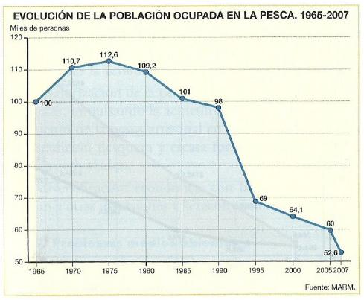
Fishing
Analyse the following chart and answer to the following questions:
- What does it represent?
- What is the trend?
- Give reasons.


How to analyse images
Part 1: Description (Analysis)
In this part you can only write about the things that you see in the photograph. (You may know many things but now is not the moment to write them)
Here you have to describe physical characteristics of the landscape, such as relief (flat or steep relief, mountainous relief, a valley…), climate and vegetation.
Types of Climates
Dry or humid,
Hot climates: equatorial, tropical, hot desert.
Types of tropical climate: Humid Tropical Climate, Dry Tropical Climate and Monsoon Climate.
Temperate climates: Mediterranean, continental, oceanic.
You will also have to describe the agricultural characteristics, such as size and shape of plots of land, type of crops, people working, tools, process (only what you see, remember, such as planting, harvest, irrigation, weeding…)

Part 2: Deduction
Here you only have to deduce the type of agricultural landscape that you are seeing.
You can use this type of introductions.
Because of all these characteristics I can deduce that this image represents the ……
Due to all of these elements I can say, suppose, figure out, assume… that it is a ….
It’s just two lines (you only have to say what type of Agricultural Landscape is in the photograph).

Part 3: Commentary
- Here you have to explain the agricultural landscape and all its characteristics.
- You have to mention constantly the photograph (remember that you are analysing one photograph, not explaining one topic).
- Here you can explain the things that you have mentioned before in the description
- And you can also explain things that you cannot see in the photograph but that you know.
- You can explain:
  - Location
  - Crops
  - Processes
  - Others… (What is market economy, subsistence economy, types of tools...)

Part 4: Others
At the end, and only at the end, you can write things such as:
Your personal opinion
Consequences
Other ideas such as environmental problems, economic consequences….

Some Key Vocabulary
- For describing what you see: I see, I can see, I observe, I notice...
- For locating items in the photograph: In the foreground (en primer plano), in the background (al fondo), at the upper left corner, at the upper right corner, at the lower right corner, at the lower left corner, at the left, at the right, at the top, at the bottom...
- For deductions: I deduce, I assume, I figure out, I suppose, I infer, I understand...
- For the causes: this situation is caused/produced/provoked/generated/created by
- For the consequences: Because of this/that, for this reason, as a result, therefore (por tanto), in consequence, consequently, so....
- Giving your opinion: I think, In my opinion, In my view, To my mind, As far as I am concerned.....
- Concluding: In conclusion, To conclude, To summarise...

