Unit 2 – The Primary Sector
INDEX
1. Introduction 2
1.1. What is Primary Sector? 2
1.2. What are agriculture, livestock farming, forestry and fishing? 2
1.3. Distribution of agriculture in the world. 2
2. Natural Factors 3
2.1. Climate 3
2.2. Relief 3
2.3. Soil and Vegetation 4
3. Human Factors 4
3.1. Population 4
3.2. Technology 4
3.3. Society 4
4. Agricultural Landscapes 5
4.1. Features of agricultural landscapes. 5
a) Fields or Plots of land 5
b) Other Features: 5
c) Rural Settlement 6
4.2. Types of Agricultural Landscapes 6
5. Traditional Agricultural Landscapes 7
5.1. Itinerant or “slash and burn” agriculture. 7
5.2. Dry Sedentary Agriculture 7
5.3. Monsoon Irrigation Agriculture 7
6. Developed Agricultural Landscapes 7
6.1. The agriculture of new-world countries 8
6.2. Plantation Agriculture 8
6.3. Other Types of Agricultural Landscapes 8
7. Livestock Farming 8
7.1. Traditional Livestock Farming 8
7.2. Market Livestock Farming 9
8. Fishing 9
9. Forestry 9
10. Environmental problems and possible solutions 9
10.1. Agriculture and Livestock Farming 9

Introduction

What is Primary Sector?
Primary sector includes the economic activities related to obtaining resources from nature; these activities are agriculture, livestock farming, forestry and fishing.

What are agriculture, livestock farming, forestry and fishing?
All of them are economic activities aimed to obtain natural resources from the environment whether for consumption or for being used in industry.
- Agriculture: refers to the cultivation of land in order to obtain different crops that later will be used as food, fodder (pienso, forraje) for animals, and also as raw materials for industry. Some examples may be cereals (wheat, oat, barley…), fruits, flowers, cotton, tobacco, cocoa…
- Livestock farming: consists of the raising of animals in order to obtain products for human use. These products will be used as food for human consumption (milk, meat, eggs…) and also as raw materials for industry (wool, leather, natural fertilizers…).
The most common species are cows (cattle), sheep and goats, pigs, poultry…
- Forestry: is the managing of forests in order to obtain raw materials. These materials are wood or timber, resins (used in the pharmaceutical industry), rubber (caucho)…
- Fishing: is any economic activity that obtains raw materials from the sea.

Distribution of agriculture in the world.
Approximately a 39% of the world population works in agriculture. This percentage varies significantly depending on the country. For example in Spain a 2,9% of the population works in agriculture, while in Burkina Faso (Central Africa) a 90% of the population work in agriculture.
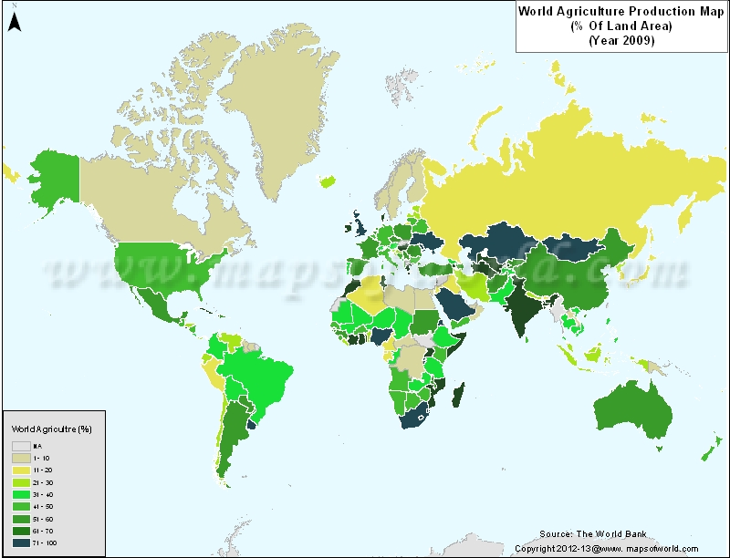
Source: http://www.mapsofworld.com/thematic-maps/world-agricultural-production.html

Natural Factors
Obviously agriculture is influenced by natural factors; into these natural factors we can consider climate, relief and type of soil.

2.1. Climate
The type of climate is decisive for choosing the type of crops that we will plant and grow. A climate tells us information about the humidity, the temperature and the amount of light received in that area.
Some climates are good for agriculture (like rice in monsoon climate) and some climates are so extreme that are only good for livestock farming (in the European polar circle nomadic livestock farming with reindeers is practiced).
The climates that we have in our planet are:
 Remember the Climates
Hot Climates | - Equatorial Climate (Tropical Rainforest)  - Tropical Climate  - Humid Tropical Climate, (Tropical rainforest)  - Dry Tropical Climate (Savannah)  - Monsoon Climate  - Hot Desert Climate
Temperate Climates | - Mediterranean Climate  - Oceanic Climate (Deciduous forest)  - Continental Climate (Taiga)  - Chinese Climate
Cold Climates | - Polar Climate (Tundra)  - Mountain Climate

2.2. Relief
It’s obvious that the land relief is important for primary activities. Agriculture is better adapted to flat areas, like alluvial plains or valleys. These areas are also more fertile thanks to the soil that is accumulated there.
In the mountainous areas is harder to cultivate the land because the steep slopes cause erosion and the soil (and nutrients) are carried away by water. These steep slopes also make more difficult the access of machinery. The best agricultural activities for mountainous areas are livestock farming and forestry.
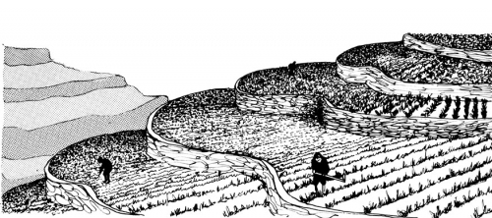
Note: sometimes, when some areas are very populated the mountainous areas are cultivated thanks to the use of terraces. Thanks to these terraces (bancales) farmers are able to use most of the land for agriculture.

2.3. Soil and Vegetation
Soil and vegetation are two more natural factors.
- Soil is easy to understand as the meaning of soil is the portion of the earth's surface consisting of disintegrated rock and humus. Besides the meaning of humus is the dark organic material in soils, produced by the decomposition of vegetable or animal matter and essential to the fertility of the earth.
The better soils are found in alluvial plains and valleys.
- Vegetation is also very important because it prevents erosion and the disappearance of soil and nutrients.

Human Factors
Human beings cause an inevitable impact in the agricultural landscapes. Population, technology and the society itself can influence on the agricultural production.

3.1. Population
Due to the population explosion the demand of agricultural products has increased dramatically. As a consequence more land is needed for crops and for animals and that is going to mean an environmental impact on the natural landscapes.
Some environmental problems caused by this higher demand can be:
- Deforestation
- Overexploitation of the land
- Danger of extinction for some species
- Decrease of the genetic diversity
- Excessive use of pesticides
- Abuse of fertilisers that may cause eutrophication. (The artificial nutrients go into the river and can make water plants and algae grow, use all the oxygen and suffocate the fish and animals that live in the rivers).

3.2. Technology
Technology is a very influential human factor. Recent technological advances have helped to increase the production and to modify unfavourable natural conditions.
In traditional societies the tools that are used are very simple. Some examples are the digging stick, the hoe (azada), the sickle (hoz) and the plough (arado), they can also use wells (pozos), canals (acequias), inundation canals (riego por inundación)…
In developed societies and in developed agricultural landscapes we can find modern equipment such as tractors, harvesters, chemical pesticides, chemical fertilisers, greenhouses, hydroponic crops (cultivation without land), drip irrigation (riego por goteo), selection of seeds and breeds, GMO (Genetically Modified Organisms), investments in research and development.

3.3. Society
The crops and foods that are produced are aimed to a specific society. In this aspect we can observe two types of agricultural systems, the subsistence economy and the market economy.
- In the subsistence economy the food that is produced is for the needs of the local people that live in the farm, the village or the local market. They use to produce many types of crops and animals, and enough food to satisfy their needs.
- In the market economy the food that is produced is for the markets (domestic or international markets). They usually specialise in one single product, and they try to produce high quantities.

Agricultural Landscapes
In this section we will study the different agricultural landscapes that we can find in our planet Earth.

4.1. Features of agricultural landscapes.
Here you will find some terms that are essential in order to understand the different agricultural landscapes that we will analyse in this unit.

Fields or Plots of land
A field refers to the division of agricultural land. They can be regular or irregular; small, medium-sized or large, enclosures or open fields.

Plots of Land or Fields
Shape: | Regular |  | Irregular
Size: | Small: | Medium: |  | Large:
Size: | Smallholdings  (less than 10 hectares) | (10 – 100 hectares) |  | Large estates  (more than 100 hectares)
Limits: | Open fields:  The fields have no fences |  | Enclosures:  The fields are closed with fences

Other Features:
Variety of Crops: | Polyculture: Many types of crops are planted | Monoculture: only one type of crop is planted
Irrigation system: | Dry farming: crops only receive water from precipitation. | Irrigation: water is supplied artificially from rivers. It requires large investment in infrastructure, such as dams, canals, drip irrigation...
The use of the land: | Rotation: they let part of the land to fallow (uncultivated). It can be a two-year rotation or a three-year rotation. | Constant cultivation without letting the land to rest. It includes the use of fertilisers
How the land is worked: | Extensive: these farms have, in comparison, small inputs of money (investments) for large areas of land.  The farms are usually big.  Examples:  Cattle ranching on the prairies, USA.  Dry Sedentary agriculture. | Intensive: the farms have high inputs (investments) of money in order to achieve the maximum benefit per hectare.  The farms are usually quite small.  Examples: greenhouse cultivation,  Monsoon agriculture.
Destination of the crops: | Subsistence agriculture: the products are used to feed the family or the village.  It is usually associated with polyculture | Market agriculture or commercial :  They produce for the domestic or international market.  It is usually specialised in only one crop (monoculture).

Rural Settlement
Rural settlement is how the population, houses and villages are distributed in the landscape.
- We can talk about disperse rural settlement when the houses separated and surrounded by fields.
- We can talk about concentrated rural settlement when the houses are constructed next to others, forming a village. The houses can be placed all along a path or road, this is called lineal settlement, or placed around a centre, and this is called clustered settlement.
- We can also observe the intermediate rural settlement that is a mixture of these two previous examples. We will have isolated houses and also houses packed in villages.

4.2. Types of Agricultural Landscapes
Here you have a list with most of the agricultural landscapes of the world.
(As most of the information is in this list we will only explain some characteristics).
Agricultural Landscapes
Type of agricultural landscape | Traditional or Developed | Subsistence/Market Economy | High/Low Production | High/Low Personal Labour | Dry/  Irrigated Agricult. | Regular/ Irregular Fields | Size of the Plot of Land |  | Polyculture or Monocult. | Intensive or Extens.
Slash and burn Agriculture | Traditional | Subsistance Economy | Low Production | High Personal Labour | Dry Agriculture | Irregular Fields | Small or Medium |  | Polyculture | Extensive
Location: Equatorial and Tropical climates in Africa, Central & South America, Indonesia…
Crops: cereals, sorghum (sorgo), millet (mijo), maize, cassava (mandioca), yam (ñame), sweet potatoe, etc.
Dry Sedentary Agriculture | Traditional | Subsistance Economy | Low Production | High Personal Labour | Dry Agriculture | Irregular Fields | Small (Smallholding) |  | Polyculture | Extensive
Location: Located in the Tropical Savannah areas of Africa and in certain regions of South America & Asia. They are sedentary and they use the rotation system and natural manure.
Crops: millet, maize, peanuts, tubers (tubérculos)…
Monsoon Irrigation Agriculture | Traditional | Subsistance Economy | High Production | High Personal Labour | Irrigated Agriculture | Regular Fields | Small & Medium | Monoculture |  | Intensive
Location: Located in areas with monsoon climate (very humid), such as India, China, Vietnam, Laos, Thailand, Cambodia or the Philippines.
Crops: rice
Agriculture of new-world countries | Developed | Market Economy | High Production | Low Personal Labour | Both (Depending on the Crops) | Regular Fields | Big (Large) Estates | Monoculture |  | Extensive
Location: Located in North & South America (USA, Canada, Argentina) and Australia. Areas with vast extensions of land.
Crops: wheat, maize, tobacco, cotton, etc.
Plantation Agriculture | Developed | Market Economy | High Production | High Personal Labour | Dry Agriculture | Regular Fields | Big (Large) Estates | Monoculture |  | Extensive
Location: Located in areas with humid tropical climates in Central and South America, south-east Asia and the Gulf of Guinea in Africa.
Multinational companies plant the products in underdeveloped countries and later sell the final product in developed countries in order to obtain benefit.
Crops: There are food crops and industrial crops, such as coffee, sugar cane, cocoa, bananas, pineapples, rubber, cotton, palm oil.

Traditional Agricultural Landscapes
In general a traditional landscape or subsistence landscape is characterised by its primitive technology, polyculture, low production, high labour…

Itinerant or “slash and burn” agriculture.
- Location, crops and others: see the list.
We usually can find irregular plots of land in the middle of equatorial and tropical rainforests.
The process requires a lot of labour. First you have to clear the forest (slash=cortar), cut the trees and the weeds (malas hierbas). Later the trees and the weeds are burnt, and the ashes will fertilise the soil thanks to the rain. They plant crops for self-consumption (polyculture and subsistence economy).
The land is cultivated continuously and when it becomes exhausted (3 or 5 years) the farmers move to another area and repeat all the process.
This system is only sustainable with scarce population, as few people have at their disposal vast areas of tropical rainforest. We must also consider that after some years the farmers may return to the first plot of land that will be regenerated.

Dry Sedentary Agriculture
  - Location, crops and others: see the list.
The most important fact about this system is that they are sedentary (obviously!). This fact is going to imply many other characteristics. As they don’t move they will use natural manure and fallow so that the land don’t become infertile. Remember that we are talking about a traditional system and because of that they won’t use chemical fertilisers, or irrigation systems.
The plots of land are small and near the houses, they produce for their subsistence (polyculture and subsistence) and they don’t use irrigation systems (have in mind that we are in dry climates and there is not much water). It is also extensive as they don’t invest and don’t try to obtain the maximum benefit from the land.

Monsoon Irrigation Agriculture
  - Location, crops and others: see the list.
This agricultural landscape, although is also a traditional landscape, is very different from the previous ones. They have a high production and it is intensive and monoculture.
The typical monsoon irrigation landscape is full of paddies (fields of rice surrounded by a dyke and inundated with water).
Process:
The process is a little bit more complex. First they plant the rice in a nursery, treated with manure. Meanwhile the paddies are ploughed, fertilised and flooded (inundated). The plants are transplanted in the paddies and when they grow the water in drained off and the rice is harvested and prepared for consumption.
It is intensive because they invest a lot of labour and obtain the maximum benefit. In this system they can produce two or three harvests per year.

Developed Agricultural Landscapes
In this type of landscape the farmers use advanced technology and they produce for the market. The production is very high, but the labour is very low thanks to the use of machinery. The farmers specialise in one or two crops (monoculture).

The agriculture of new-world countries
  - Location, crops and others: see the list.
This type of landscape is characterised by regular fields, use of most advanced technology (machinery, fertilisers, pesticides, selection of seeds, GMOs…). Thanks to that the production is very high and the need of labour is very low. It’s a market economy, as they produce for the market and try to obtain the maximum benefit. It’s also monoculture and depending on the type of crop, process and production, it can be intensive or extensive.
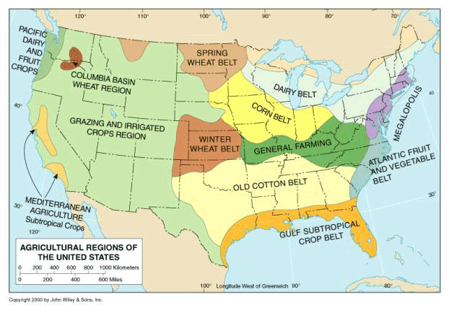
Note: the belts are very common in this agricultural landscape. They are very typical in the USA and consist of belts of land that are specialised in one crop according to the climate and soil. Some crops are cotton, tobacco, maize, wheat…; in drier areas, where agriculture is not possible, livestock farming is the best option (cattle or sheep).

Plantation Agriculture
- Location, crops and others: see the list.
The plots of land are large; the technology is very advanced as the plantation belongs to multinationals. Although there is a high level of technology they also require high labour, as some tasks can’t be mechanised.
The multinationals that are the owners of the plantations have a market mentality and they try to obtain the maximum benefit. They obtain cheap labour and cheap crops in developing countries and sell the manufactured products (tobacco, chocolate, coffee, fruits, sugar…) at high prices in developed countries.

Other Types of Agricultural Landscapes
There are more types of agricultural landscapes that are not included here.
Some examples are Greenhouse Agriculture, Mediterranean irrigation agriculture, Organic Agriculture, Orchard Agriculture…

Livestock Farming

Traditional Livestock Farming
It’s a subsistence economy, as they produce for their needs, and they use traditional technology.
There are many examples of this traditional model, but we will focus on the most important ones:
- Nomadic Livestock Farming: we find this system near the deserts. Farmers are forced to move constantly looking for pasture. The animals are usually camels, goats and sheep. Some examples are Tuaregs in the Sahara and the Bedouins of the Arabian Peninsula.
- Transhumant Livestock Farming: farmers move seasonally from mountainous areas (summer pasture) to valleys (winter pasture). It can be found in many areas of America, Europe, Asia and North Africa. Some examples are “La Mesta”, a transhumant organisation in Spain that was created in 1273; the Sami People, with their herds of reindeers or the Mongols with their herds of sheep, goats, horses and cattle.

Market Livestock Farming
Vocabulary:
Herd: manada. Herd of camels, herd of goats.
Graze: pastar
Pasture: pastos
Shepherd: pastor
It is more typical in developed areas, but we can find it in developing areas too. Its main characteristic is that they produce for the market. We can find two types.
- Extensive Livestock Farming: the livestock grazes in the open air. It doesn’t require much investment in stables, facilities or labour. It is very typical in the prairies of North America, in Australia and in the Pampas of Argentina.
- Intensive Livestock Farming: livestock is sheltered in stables and fed with animal feed (piensos). It requires more investment in labour, stables, facilities, veterinary care, selection of breeds, animal feed, technology…
The farms are usually near the cities in order to reduce costs of transport.

Fishing
Vocabulary
Fishing grounds or banks: They are areas where the fish is more abundant.
Depending on the distance from the coast we can find
- Coastal fishing, when fishermen go out and return every day.
- Offshore fishing, when fishermen go out and remain some days.
- Deep-sea or High-sea fishing, when ships go out and remain weeks or even months.

Forestry
- Definition: see page 2
This activity is usually practiced in the rainforest and tropical forests, where trees grow rapidly.
But it is also very common in the taiga forests, where the coniferous trees are very abundant. The taiga forests are located in areas with continental climate in the Northern hemisphere.

Environmental problems and possible solutions

Agriculture and Livestock Farming vs. Organic Farming
In Agriculture we have already seen some environmental problems. Here you can see them again.
- Deforestation
- Overexploitation of the land
- Danger of extinction for some species
- Decrease of the genetic diversity
- Excessive use of pesticides
- Abuse of fertilisers that may cause eutrophication. (The artificial nutrients go into the river and can make water plants and algae grow, use all the oxygen and suffocate the fish and animals that live in the rivers).
- The use of Genetically Modified Organisms, GMOs
- The multinationals and a market economy that only want to obtain the maximum benefit and don’t care about the environment.
- A possible solution can be the Organic Farming. This type of farming relies on traditional techniques such as natural manure, rotation of the land, use of local crops, biological pest control (mixed cropping and insect predators). GMOs are forbidden as well as most of the chemical products.
What is sustainable?
It is when an economic activity is capable of being practiced at a steady level without exhausting natural resources or causing severe ecological damage.
In livestock farming hormones and antibiotics are forbidden and animals live in better conditions.
This type of agriculture appeared in the 20th century due to an environmental mentality.
The aim is to respect the environment, to produce healthy products and to create a sustainable economic activity.
Another interesting environmental proposal is to promote the local farmers in the markets. Thanks to this the cost of transport and emissions of CO₂ are reduced. But the most important aim is to protect local farmers against competition of multinationals. It is called “Food Sovereignty” (it expresses the right of the people to produce their own food without depending of foreign producers).

Forestry vs. Silviculture
Excessive exploitation of the forests is a very serious environmental problem. A wise solution to this problem is silviculture. Silviculture is a controlled exploitation of the forest that looks for a sustainable economic activity. In this environmental alternative the objective is to take care of the vegetal species and plant new trees so that the forest can be exploited in a continuous way without suffering a considerable threat.

Fishing vs. Aquaculture
Aquaculture consists in the cultivation of aquatic animals and plants (fish, seaweed –algas-, crustaceans, molluscs…) in an artificial and controlled environment.
On the one hand this technique can avoid the exploitation of some marine species and protect the wildlife; however on the other hand this technique has been criticised because of the use of antibiotics, the waste produced by animals, the use of animal feed (piensos), or the propagation of invasive species.
Another solution can be the establishment of quotas and limits by the governments. Thanks to legislation the governments can limit the quantity of fish and the number of species that can be fished. This will protect some specific species and will allow a sustainable exploitation of the seas.

======ooo000ooo======

Remember that sheep can be used as a singular and a plural, without carrying the “s”. E.g.: a sheep is a farm animal. Or Sheep are farm animals.

