Unit 1 – Activities - Economy
INDEX
1. Introduction 1
2. Economic Sectors 1
3. Globalisation 4
4. Economic systems 6
5. The Labour Market 6
6. Unemployment in Spain 7

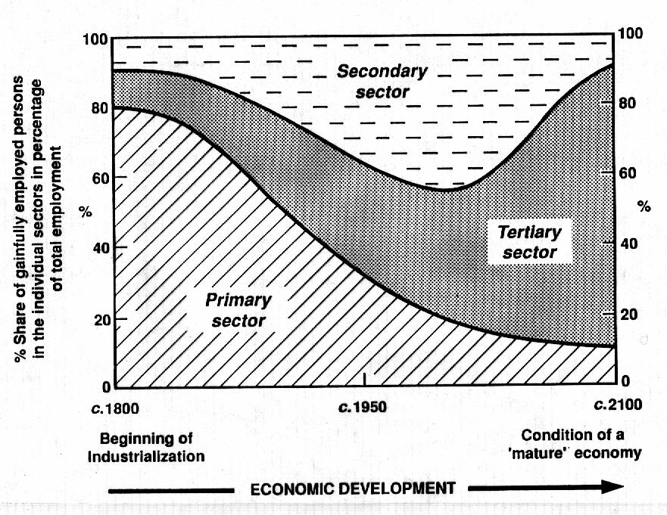
Introduction
- Explain the following graph.
What does it represent? What is the distribution of each sector? Why has it happened?

Economic Sectors
- Here you have some countries with the distribution of economic sectors. Choose one and answer to these questions:
  - What type of country do you think it is? (LEDC, NIC, MEDC…)
  - Why do you think that? (Explain your answer in 4 lines maximum)
  - Is there much or little difference between GDP and GDP per capita? What is the meaning of that?
  - Explain the employment structures and its distribution in the three different sectors?
  - Compare the GDP per economic sectors and Labour force by sectors. Is there much difference? Explain this difference.
Country | Nº | GDP | GDP per capita | GDP per economic Sectors | Labour force by sectors
Spain -0- | 0 | $1.572 trillion (2014 est.)  Position: 17 | $33,800 (2014 est.)  Position: 54 | agriculture: 2.5%  industry: 23.1%  services: 74.4% (2014 est.) | agriculture: 2.9%  industry: 15%  services: 58.4% (2014 est.)

Nº | GDP | GDP per capita | GDP per economic Sectors | Labour force by sectors
1 | $181.2 billion (2014 est.)  Position: 64 | $11,300  (2014 est.)  Position: 128 | agriculture: 6%  industry: 34.3%  services: 59.7% (2014 est.) | agriculture: 27.8%  industry: 17.8%  services: 54.4% (2012)

Nº | GDP | GDP per capita | GDP per economic Sectors | Labour force by sectors
2 | $540.9 billion (2014 est.)  Position: 35 | $17,800 (2014 est.)  Position: 95 | agriculture: 3.6%  industry: 33.4%  services: 63% (2014 est.) | agriculture: 7.3%  industry: 21.8%  services: 70.9% (4th quarter, 2011 est.)

Nº | GDP | GDP per capita | GDP per economic Sectors | Labour force by sectors
3 | $372.7 billion (2014 est.)  Position: 48 | $11,900 (2014 est.)  Position: 124 | agriculture: 7%  industry: 35.5%  services: 57.5% (2014 est.) | agriculture: 25.8%  industry: 17.4%  services: 56.8% (2011)

Nº | GDP | GDP per capita | GDP per economic Sectors | Labour force by sectors
4 | $18.38 billion (2014 est.)  Position: 147 | $1,800 (2014 est.)  Position: 207 | agriculture: 23.4%  industry: 19.8%  services: 56.8% (2014 est.) | agriculture: 38.1%  industry: 11.5%  services: 50.4% (2010)

Nº | GDP | GDP per capita | GDP per economic Sectors | Labour force by sectors
5 | $24.1 billion (2014 est.)  Position: 136 | $8,600 (2014 est.)  Position: 141 | agriculture: 6.9%  industry: 21.2%  services: 72% (2014 est.) | agriculture: 17%  industry: 19%  services: 64% (2006)

Nº | GDP | GDP per capita | GDP per economic Sectors | Labour force by sectors
6 | $259.2 billion (2014 est.)  Position: 57 | $7,800 (2014 est.)  Position: 148 | agriculture: 13%  industry: 29.3%  services: 57.7% (2014 est.) | agriculture: 39.1%  industry: 20.3%  services: 40.5% (2014 est.)

Nº | GDP | GDP per capita | GDP per economic Sectors | Labour force by sectors
7 | $29.42 billion (2014 est.)  Position: 128 | $1,700 (2014 est.)  Position: 212 | agriculture: 22.4%  industry: 26%  services: 51.6% (2014 est.) | agriculture: 90%  industry and services: 10% (2000 est.)

Nº | GDP | GDP per capita | GDP per economic Sectors | Labour force by sectors
8 | $5.896 billion (2010 est.)  Position: 169 | $600 (2010 est.)  Position: 229 | agriculture: 60.2%  industry: 7.4%  services: 32.5% (2013 est.) | agriculture: 71%  industry and services: 29% (1975)

Nº | GDP | GDP per capita | GDP per economic Sectors | Labour force by sectors
9 | $1.357 trillion (2014 est.)  Position: 19 | $17,400 (2014 est.)  Position: 96 | agriculture: 9.2%  industry: 37.7%  services: 53.1% (2014 est.) | agriculture: 16.3%  industry: 35.1%  services: 48.6% (2013 est.)

Nº | GDP | GDP per capita | GDP per economic Sectors | Labour force by sectors
10 | $2.686 trillion (2014 est.)  Position: 9 | $10,700 (2014 est.)  Position: 131 | agriculture: 13.7%  industry: 42.9%  services: 43.3% (2014 est.) | agriculture: 38.9%  industry: 13.2%  services: 47.9% (2012 est.)

Nº | GDP | GDP per capita | GDP per economic Sectors | Labour force by sectors
11 | $4.767 trillion (2014 est.)  Position: 5 | $37,500 (2014 est.)  Position: 44 | agriculture: 1.2%  industry: 26.8%  services: 72% (2014 est.) | agriculture: 2.9%  industry: 26.2%  services: 70.9% (February 2015 est.)

Nº | GDP | GDP per capita | GDP per economic Sectors | Labour force by sectors
12 | $18.09 trillion (2014 est.)  Position: 2 | $13,200 (2014 est.)  Position: 117 | agriculture: 9.2%  industry: 42.7%  services: 48.1%  (2014 est.) | agriculture: 33.6%  industry: 30.3%  services: 36.1%  (2012 est.)

Nº | GDP | GDP per capita | GDP per economic Sectors | Labour force by sectors
13 | $420 billion (2014 est.)  Position: 43 | $24,100 (2014 est.)  Position: 76 | agriculture: 4.7%  industry: 36%  services: 59.3% (2014 est.) | agriculture: 25.8%  industry: 11.9%  services: 62.3% (2012)

Nº | GDP | GDP per capita | GDP per economic Sectors | Labour force by sectors
14 | $17.35 trillion (2014 est.)  Position: 3 | $54,400  (2014 est.)  Position: 19 | agriculture: 1.6%  industry: 20.6%  services: 77.8%  (2014 est.) | farming, forestry, and fishing: 0.7%  manufacturing, extraction, transportation, and crafts: 20.3%  managerial, professional, and technical: 37.3%  sales and office: 24.2%  other services: 17.6%

Nº | GDP | GDP per capita | GDP per economic Sectors | Labour force by sectors
15 | $2.149 trillion (2014 est.)  Position: 12 | $18,000 (2014 est.)  Position: 92 | agriculture: 3.5%  industry: 33.8%  services: 62.7% (2014 est.) | agriculture: 13.4%  industry: 24.1%  services: 61.9% (2011)

List of countries (Activity #2)
1 – Ecuador  2 - Venezuela  3 - Perú  4 -Haití  5 - Jamaica | 6 - Morocco  7 – Burkina Faso  8 - Somalia  9 – Irán  10 - Indonesia | 11 – Japan  12 – China  13 – Kazakhstan  14 – USA  15 - Mexico

Globalisation
- Analysis of an image.
- Here you have the different steps that you have to follow for a fantastic analysis and some useful vocabulary.
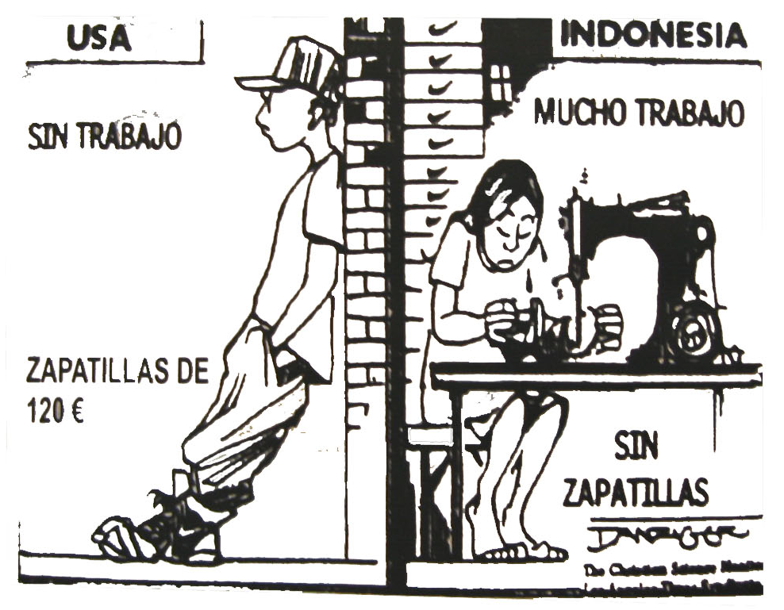

Analysis of an image
- Description (or Analysis): describe the image from the general to the particular, paying special attention to the geographical characteristics.
  - You can use the following vocabulary:
- It is a photograph, a map, a plan, a diagram, a pie diagram, a bar diagram, a cartoon, a drawing…
- At the top, at the bottom, in the middle, at the background, at the foreground…

- Short deduction: you have to deduce what is the topic (or subject) of the image. It’s just two lines (you only have to deduce the main topic).
  - You can use this type of introductions:
    - Because of all these characteristics I can deduce that this image represents the ……
    - Due to all of these elements I can say, suppose, figure out, assume… that it is a …
- Commentary: here you have to explain the characteristics of the subject, but always paying attention to the image. The image is the tool that is going to lead your commentary.
  - First mention the characteristics or the subject that the image has suggested you (and don’t forget to explain that connection).
  - Secondly explain other characteristics of the subject that are not in the image but that you know.
- Conclusion: At the end you can write things such as:
  - Your personal opinion
  - Consequences
  - Environmental problems….

Some Key Vocabulary
- For describing what you see: I see, I can see, I observe, I notice...
- For locating items in the photograph: In the foreground (en primer plano), in the background (al fondo), at the upper left corner, at the upper right corner, at the lower right corner, at the lower left corner, at the left, at the right, at the top, at the bottom...
- For deductions: I deduce, I assume, I figure out, I suppose, I infer, I understand...
- For the causes: this situation is caused/produced/provoked/generated/created by
- For the consequences: Because of this/that, for this reason, as a result, therefore (por tanto), in consequence, consequently, so....
- Giving your opinion: I think, In my opinion, In my view, To my mind, As far as I am concerned.....
- Concluding: In conclusion, To conclude, To summarise...

Economic systems
- Fill this table with the correct information. (Write full sentences in the table and you will have a powerful tool for studying).
Communist System | Capitalist System | Keynesian System | Neoliberal System
Other name:
When did it appear?
Who controls the means of production?:
Objective:
Countries:

The Labour Market
- Fill the table with the correct information.
Total Population
__________________________
___________________________
Definition:
Definition:
.
.
.
.
.
.
.
- Calculate the activity rate of the following two countries for the year 2014.
 | Total Population | Active Population | Activity Rate | Unemployment rate
Belgium | 11 237 000 | 4 975 260 |  | 8,5%
Morocco | 32 987 206 | 12 498 270 |  | 9,5 %
Romania | 21 729 871 | 9 302 000 |  | 7,3 %

- What country has the highest activity rate? ____________________
- What country has the lowest activity rate? _____________________
- Does the activity rate show only the people that are working or also other people? Explain your answer.

- Does the emigration affect the activity rate of the country of origin? Does it increase or decrease? (Explain why).

- Does the immigration affect the activity rate of the country of destination? Does it increase or decrease? (Explain why).

6. Unemployment in Spain
If you want to know more about this topic you can read the following link:
  - http://www.elespanol.com/economia/macroeconomia/20160904/152985137_0.html
- Explain the following diagram in a writing composition.
  - What does it represent?
  - The data (is it a total amount or a percentage, it increases or decreases, maximum and minimum data…)
  - Possible causes. Possible consequences
  - Personal opinion
