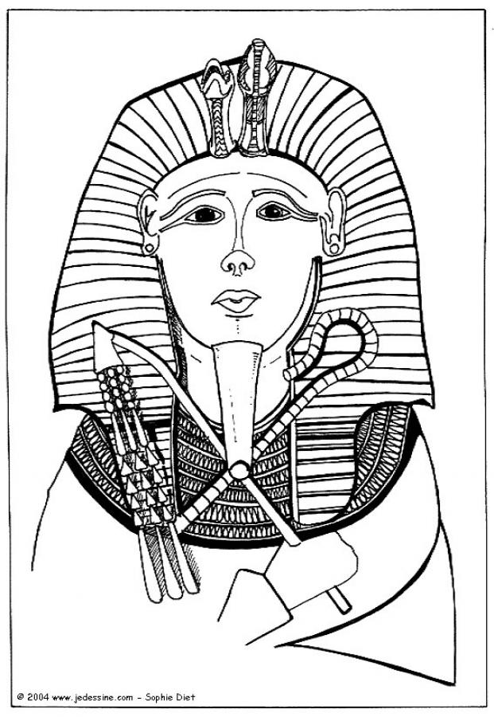
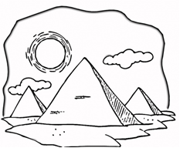
Ancient Egypt
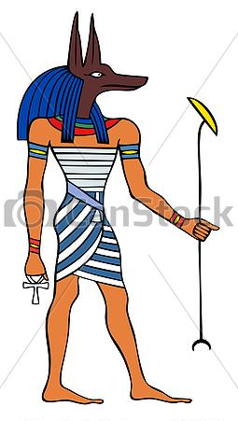
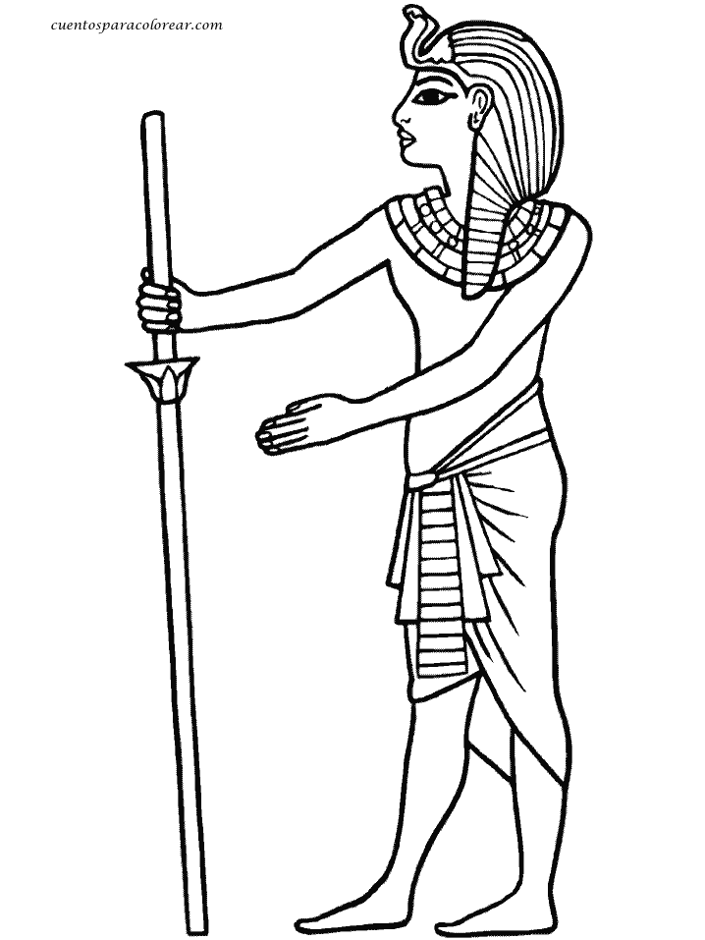
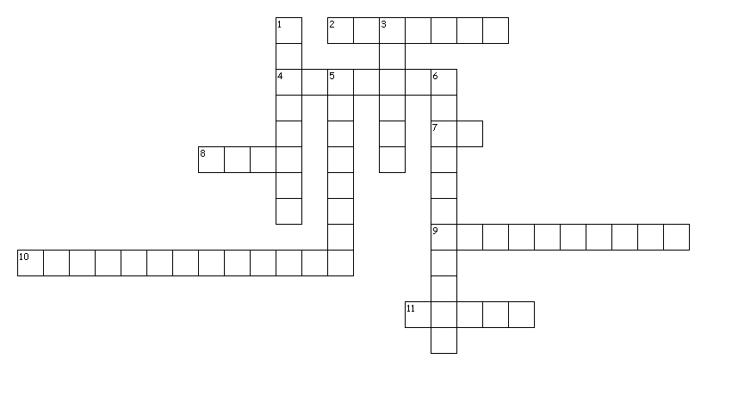

Across
2. The most ancient of tombs, shaped like truncated pyramids, inside there was a subterranean funeral chamber. (Mastaba)
4. Medium used for writing on in ancient Egypt (it was used as our paper nowadays). (Papyrus)
7. The most important of ancient Egyptian Gods. He was represented by a man with a falcon’s head, crowned with a solar disc on his head. (Ra)
8. River of ancient Egypt, provider of fertility and abundance. (Nile)
9. Pharaoh of ancient Egypt (a female pharaoh). (Hatshepsut)
10. System of writing used in ancient Egypt. (Plural) (Hyeroglyphics)
11. When someone died, the body was embalmed and converted into a ______ so that it may be preserved in the afterlife. (Mummy)
Down
1. Tomb which is excavated in a mountain. (Hypogeum)
3. Bureaucrat whose task was to compose and write official documents in Ancient Egypt. (Scribe)
5. They were the kings of ancient Egypt, they governed and ruled with absolute power. They made laws, were the heads of the army and owned most of the land. (Plural) (Pharaohs)
6. Egyptian coffin where the mummies were placed. (Sarcophagus)

