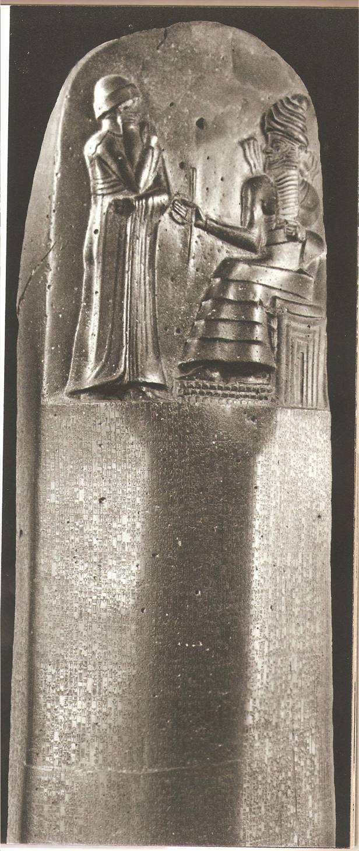
Ancient Mesopotamia
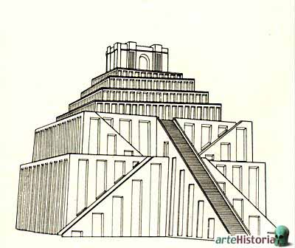
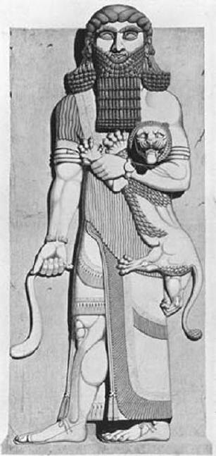
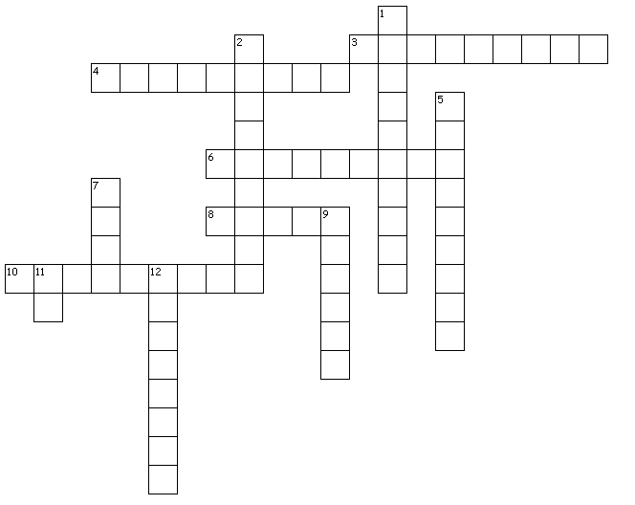
Across
3. Famous Babylonian king who lived around 1800 BCE and who created the first code of law.
4. The first empire in Mesopotamia (or the second civilization) in chronological order. (Plural).
6. Type of writing used in ancient Mesopotamia
8. One of the great contributions of Mesopotamia to Architecture.
10. One of the rivers where Mesopotamian civilizations appeared, located in the western part of Mesopotamia.
Down
1. The second empire (or the third civilization) : _____________ Empire
2. They were stair-shaped constructions situated in temples; these were sanctuaries, religious centers and astronomical observatories. The most famous one is the tower of Babel. (plural)
5. The first ancient Mesopotamian civilization. They invented writing and irrigation. (Plural)
7. One of the great contributions of Mesopotamia to Architecture.
9. One of the rivers where Mesopotamian civilizations appeared, located in the eastern part of Mesopotamia.
11. One of the most ancient cities in the world founded by the Sumerians – 25000 people lived there.
12.The third empire in ancient Mesopotamian (or the fourth civilization) (they were known for their brutality and cruelty). ___________ Empire

