EQUATORIAL CLIMATE | Location:  Located in areas near the Equator.  Latitude: 0º - 15º North and South. | Temperatures:  Temperatures are always high, (around 25º C, as an average).  It has very little variation of temperatures | Precipitations:  Very abundant and regular precipitation.  Total amount of precipitation around 2000 l/m2 | Vegetation:  Vegetation is lush with abundant plant species. These forested areas are known as Rainforest or Jungle  Some trees are 40 or 50 metres tall. | 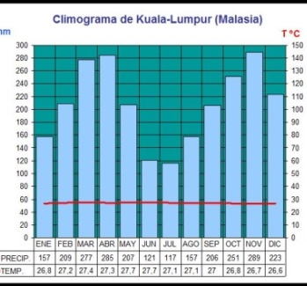
TROPICAL CLIMATE | Location:  Located after the equator and before the Tropics.  Latitude: 15º - 25º North and South. | Temperatures:  Temperatures are always high.  The variation of temperatures is a little bit higher. (Annual Average: more than 18º C) | Precipitations:  Alternation of a rainy season and a dry season (It can by dry or humid)  Total amount:  500 – 2000 l/m2  - Dry: 250-1500  - Humid: 1500-2000 | Vegetation:  Savannas: open grasslands with shrubs and isolated trees (such as baobabs and acacias).  Grass can be 4 metres high. | 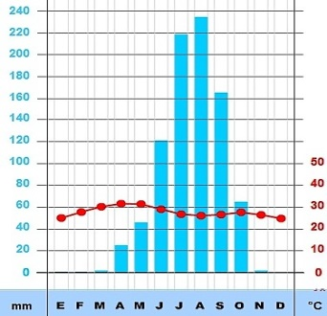
HOT DESERT CLIMATE | Location:  Located on the Tropics, near cold currents, and in the interior areas of continents.  Latitude: 23º - 30º North and South. | Temperatures:  Temperatures are very high during the day and very cold during the night.  The average temperature is very high | Precipitations:  Rainfall is very scarce and irregular.  It rains less than 250 l/m2 per year | Vegetation:  There is almost no vegetation because of the harsh climate.  In the oasis we can find date palms (palmas datileras) | 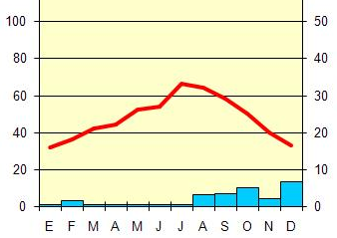
MEDITERRANEAN CLIMATE | Location:  On the coasts of the Mediterranean Sea, California, Chile, South Africa and Southern and southwest Australia.  Latitude 30º - 45 º North and South, Western coast. | Temperatures:  Temperatures are Hot in summers and winters are mild, (not really cold winters).  Little variation of temperatures. | Precipitations:  Precipitation is not abundant and is very irregular.  400 – 800 l/m2  Dry summers | Vegetation:  Evergreen trees such as pines, holm oaks and cork oaks. (pinos, encinas y alcornoques).  Scrubland formed by maquis and garrigue (maquis y garriga). | 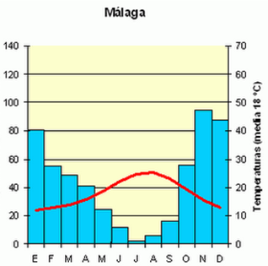

OCEANIC CLIMATE | Location: Along the western coastline of the continents. (And in the eastern coast of Australia, South Africa and in New Zealand).  Latitudes 40º/45º and 60º/65º North and south. | Temperatures:  Mild Temperatures throughout the year. (There are no hot summers and no cold winters).  Little variation of temperatures. | Precipitations:  Precipitations are abundant and regular,  (Between 600–1000 l/m2)  (They can reach 2000 l/m2) | Vegetation:  Deciduous forests (oak, chestnut and beech trees) (Robles, castaños, hayas)  Scrubland formed by moors and meadows (páramos y praderas). | 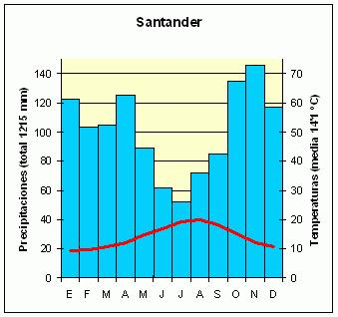
CONTINENTAL CLIMATE | Location:  Interior of Europe, Asia and North America.  Latitude: 40º - 80º approx. | Temperatures:  Temperatures are extreme:  - Hot summers  - Cold winters  High variation of temperature (even higher than 30º C of difference) | Precipitations:  Precipitations are scarce and irregular. They are concentrated in summer.  They vary between 100 l/m2 and 600 l/m2 | Vegetation:  The most common form of vegetation is Taiga with  coniferous and evergreen trees (pine, fir, cedar…), (pino, abeto, cedro…  Scrubland: steppes and prairies (estepas y praderas) | 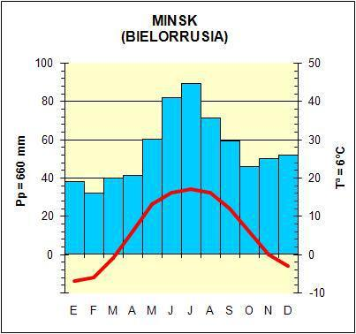
POLAR CLIMATE | Location:  It is located at the Poles:  -In the Arctic Circle  -In the Antarctic Circle | Temperatures:  Temperatures are very cold (It is the coldest climate of the Earth).  - Winters:from 0º till -50º  - Summers: temperatures  don’t exceed 10ºC | Precipitations:  Very little precipitation. Less than 300 l/m2  Usually in the form of snow | Vegetation:  Tundra in some places.  (Mosses, Lichens, small flowers and shrubs)  Cold limits the growth of vegetation. | 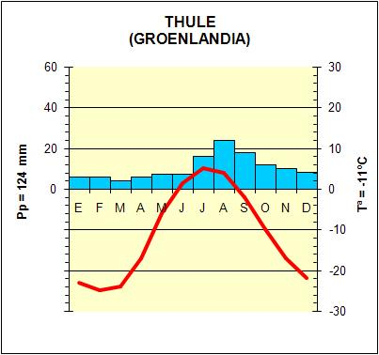
MOUNTAIN CLIMATE | Location:  It is located in the highest mountains.  Altitude over 2000 metres | Temperatures:  Winters are very cold  Summers are cool (fresco)  Temperatures decrease with altitude | Precipitations:  They are abundant throughout the year  In Winter it rains in the form of snow.  Precipitations increases with altitude. | Vegetation:  It changes with altitude.  From the bottom to the top Deciduous forest; Coniferous trees (Taiga); Shrubs; Mosses and Lichens (Tundra); and  Snow Zone | 